**Jana Cinema**

<https://janamatovic66.github.io/jana_cinema/index.html>

Smer: Internet Tehnologije

Modul: Web programiranje

Predmet: Web programiranje 2

Sadržaj

[1. Uvod 3](#_Toc65970294)

[1.1 Korišćene tehnologije 3](#_Toc65970295)

[1.2 Opis funkcionalnosti 3](#_Toc65970296)

[1.3 Template 4](#_Toc65970297)

[2. Organizacija 4](#_Toc65970298)

[2.1 Organizaciona šema 4](#_Toc65970299)

[2.2 Mapa sajta 4](#_Toc65970300)

[2.3 robots.txt 5](#_Toc65970301)

[2.4 Stranice 6](#_Toc65970302)

[2.4.1 index.html 7](#_Toc65970303)

[2.4.2 movies.html 8](#_Toc65970304)

[2.4.3 calendar.html 9](#_Toc65970305)

[2.4.4 contact.html 10](#_Toc65970306)

[2.4.5 author.html 11](#_Toc65970307)

[2.4.6 orders.html 12](#_Toc65970308)

[3.Kodovi 13](#_Toc65970309)

[3.1 HTML 13](#_Toc65970310)

[3.1.1 index.html 13](#_Toc65970311)

[3.1.2 movies.html 13](#_Toc65970312)

[3.1.3 calendar.html 13](#_Toc65970313)

[3.1.4 contact.html 13](#_Toc65970314)

[3.1.5 author.html 13](#_Toc65970315)

[3.1.6 orders.html 13](#_Toc65970316)

[3.2 CSS 13](#_Toc65970317)

[3.3 Javascript 13](#_Toc65970318)

[3.4 JSON 13](#_Toc65970319)

# Uvod

## Korišćene tehnologije

- HTML5

- CSS3

- Javascript(ES6)

-jQuery

## Opis funkcionalnosti

- Dinamičko ispisivanje menija I animacija menija na skrol nakon 50px uz pomoć jQuery biblioteke.

- Hamburger meni za male ekrane.

- Provera kontakt forme I ispis grešaka ispod input-a.

- Ispis prvih pet filmova u footer-u iz JSON-a.

- Svi filmovi, “perks” deo na index strani I komentari sa index strane su ispisani dinamički. Komentari su ispisani iz niza u javascriptu, dok su filmovi I “perks” deo iz JSON-a.

- Ddl liste za sortiranje I filtriranje su ispisane dinamićki iz JSON-a

- Filmovi se mogu filtrirati po kategorijama I sortirati po datumu I trajanju filma.

- Za čuvanje prikaza sortiranih I filtriranih filmova korišćen je local storage. Local storage je takođe korišćen za čuvanje izabranog sorta I svih filtera iz ddl lista I za rezervaciju karata za izabrani film.

- Karte se rezervišu na klik dugmeta “Get Tickets” I popunjavanjem forme koja se prikaže nakon klika. U formi korisnik bira film koji želi da pogleda, broj karata I u zavisnosti od izabranog filma se popunjava ddl lista za vreme projekcije. Forma se mora popuniti svim podacima da bi bila prosleđena na orders.html stranu.

- Na orders strani, ako nije rezervisana ni jedna karta stoji poruka korisniku da je orders strana prazna.

- Ako se izabere filter kategorije za koju ne postoji film, korisnik se obavesti alert prozorom da film za zadatu kategoriju ne postoji

## 1.3 Template

Templejet nije korišćen, pisan je samostalno.

# Organizacija

## Organizaciona šema

Svaka stranica vodi do svake stranice

## Mapa sajta

1. <?xml version="1.0" encoding="UTF-8"?>
2. <urlset xmlns="http://www.sitemaps.org/schemas/sitemap/0.9">
3. <url>
4. <loc>https://janamatovic66.github.io/jana\_cinema/index.html</loc>
5. <lastmod>2021-03-09</lastmod>
6. <changefreq>weekly</changefreq>
7. <priority>1</priority>
8. </url>
9. <url>
10. <loc>https://janamatovic66.github.io/jana\_cinema/movies.html</loc>
11. <lastmod>2021-03-09</lastmod>
12. <changefreq>weekly</changefreq>
13. <priority>.9</priority>
14. </url>
15. <url>
16. <loc>https://janamatovic66.github.io/jana\_cinema/calendar.html</loc>
17. <lastmod>2021-03-09</lastmod>
18. <changefreq>daily</changefreq>
19. <priority>0.9</priority>
20. </url>
21. <url>
22. <loc>https://janamatovic66.github.io/jana\_cinema/contact.html</loc>
23. <lastmod>2021-03-09</lastmod>
24. <changefreq>yearly</changefreq>
25. <priority>0.6</priority>
26. </url>
27. <url>
28. <loc>https://janamatovic66.github.io/jana\_cinema/author.html</loc>
29. <lastmod>2021-03-09</lastmod>
30. <changefreq>yearly</changefreq>
31. <priority>0.6</priority>
32. </url>
33. <url>
34. <loc>https://janamatovic66.github.io/jana\_cinema/orders.html</loc>
35. <lastmod>2021-03-09</lastmod>
36. <changefreq>monthly</changefreq>
37. <priority>0.7</priority>
38. </url>
39. </urlset>

## 2.3 robots.txt

User-agent:\*

Disallow:/admin/

## 2.4 Stranice

### 2.4.1 index.html

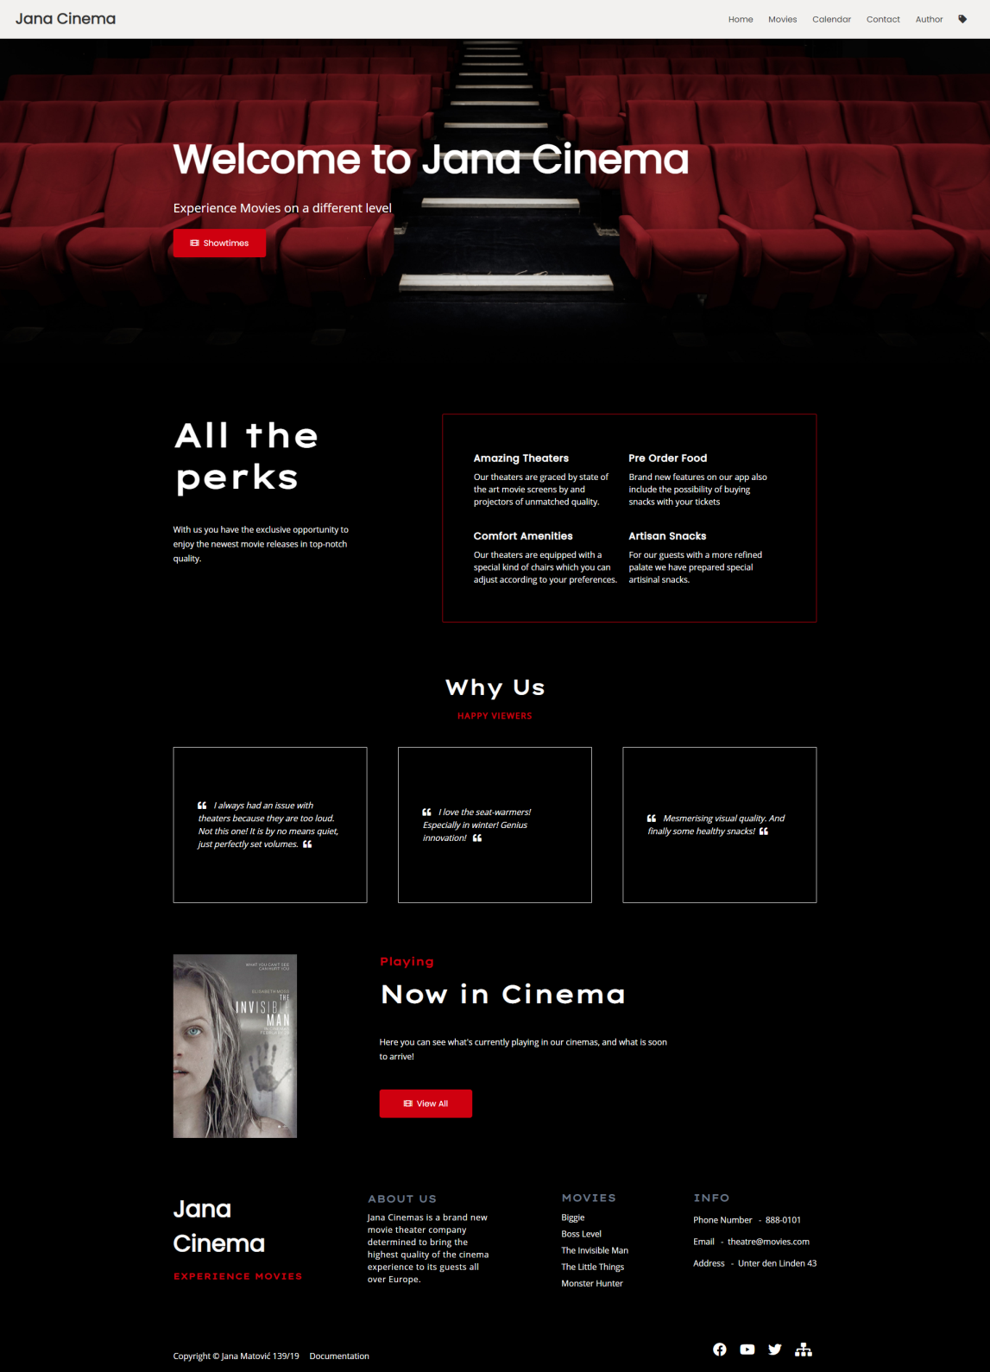

### 2.4.2 movies.html

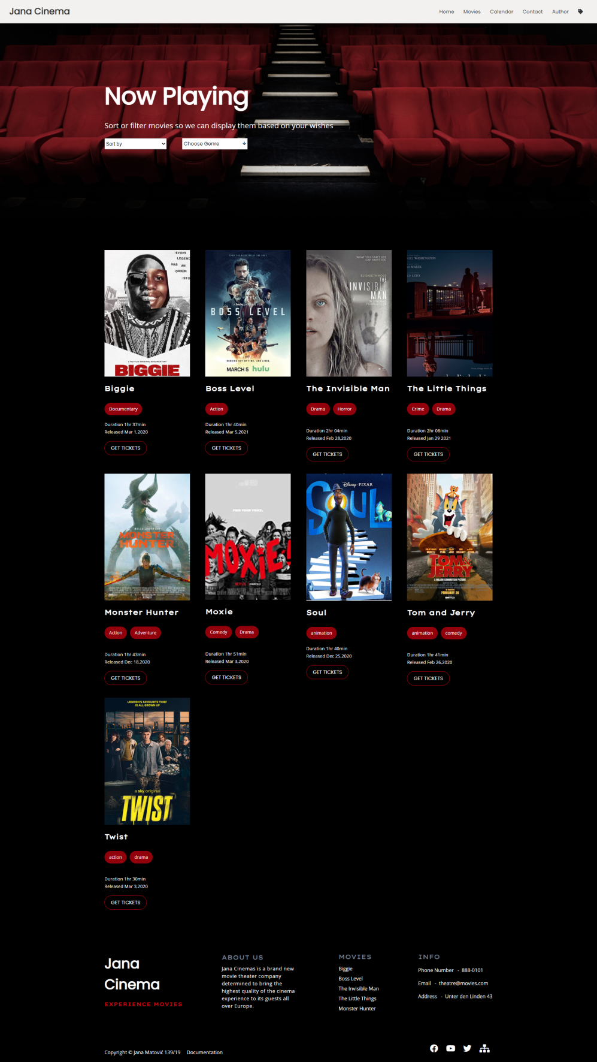

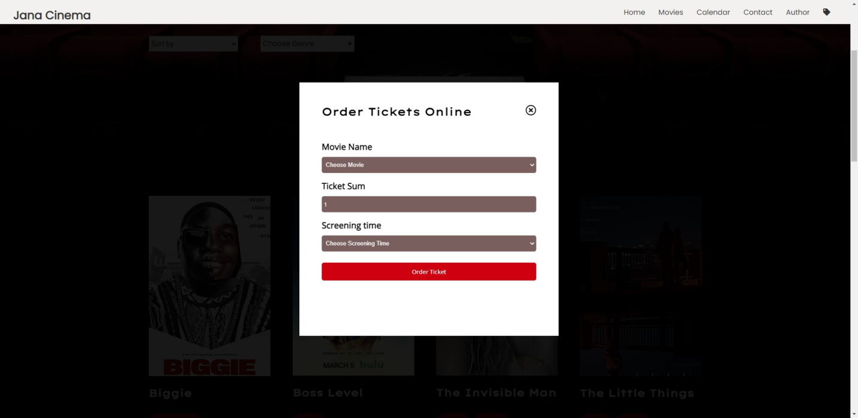

### 2.4.3 calendar.html

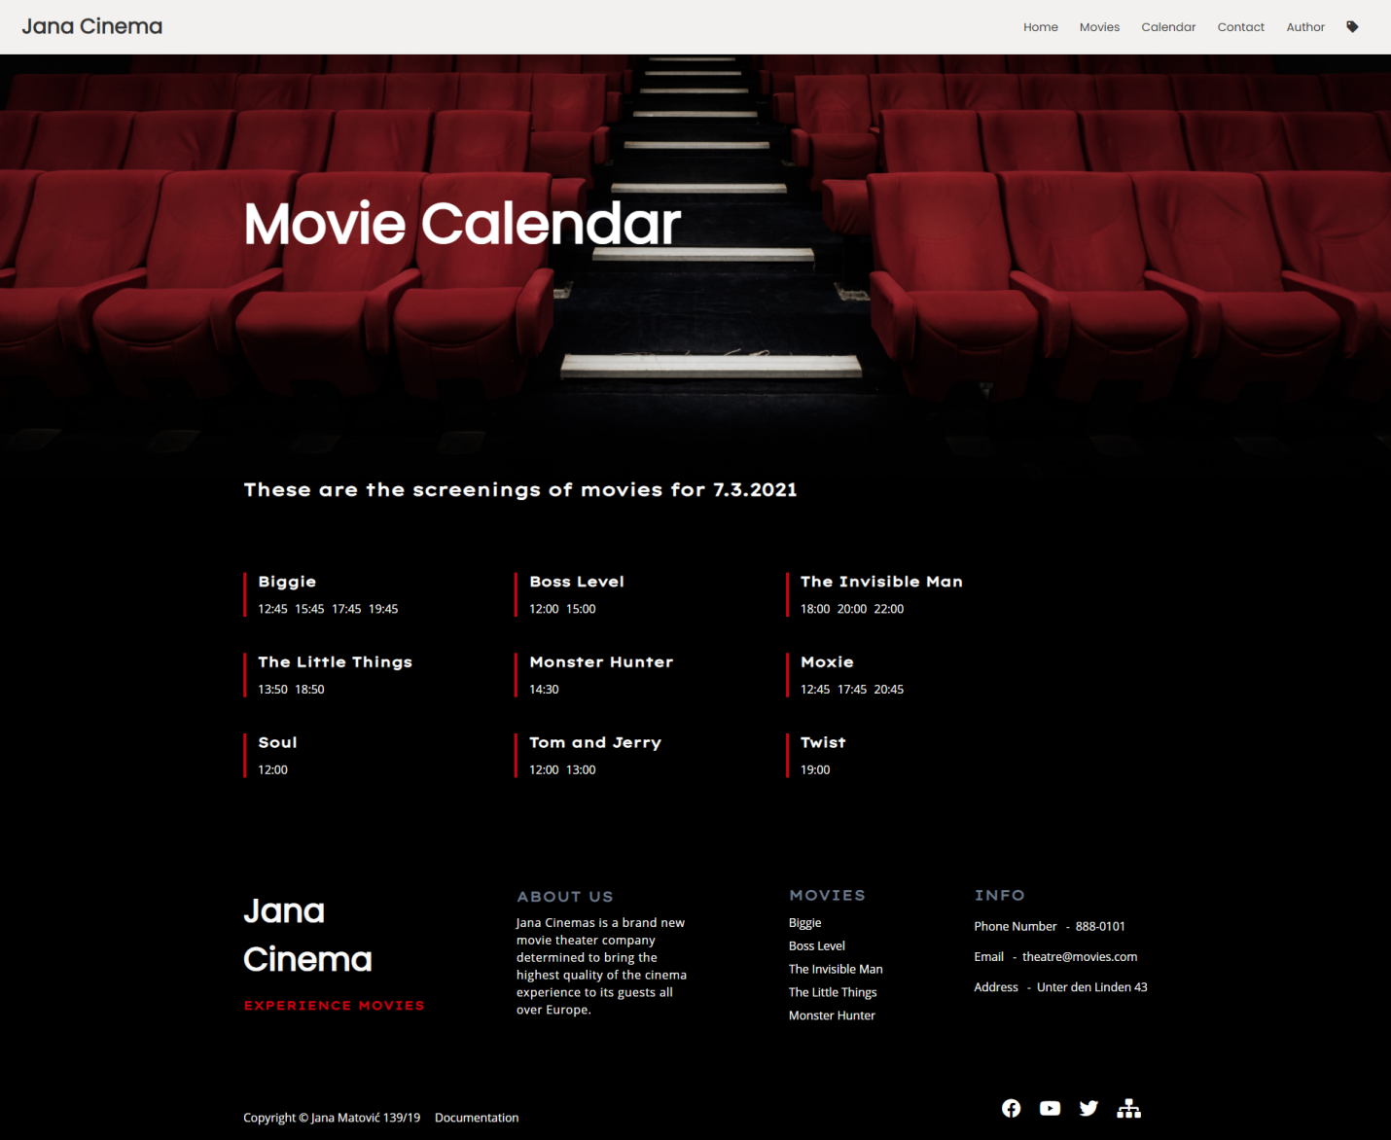

### 2.4.4 contact.html

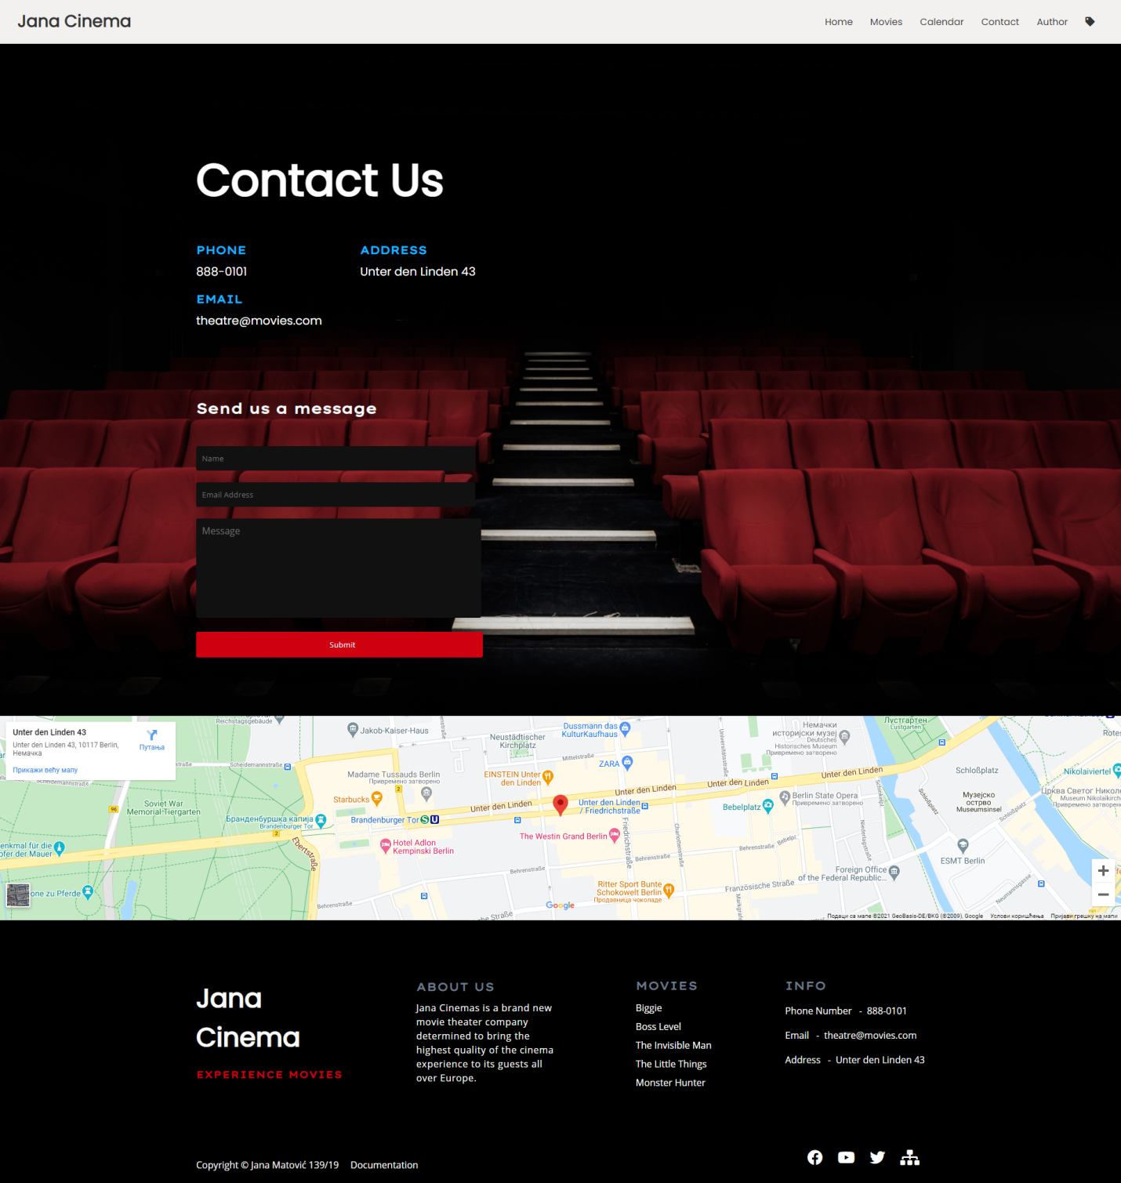

### 2.4.5 author.html

### screencapture-njevric-github-io-a-author-html-2021-03-07-00_36_18.png

### 2.4.6 orders.html

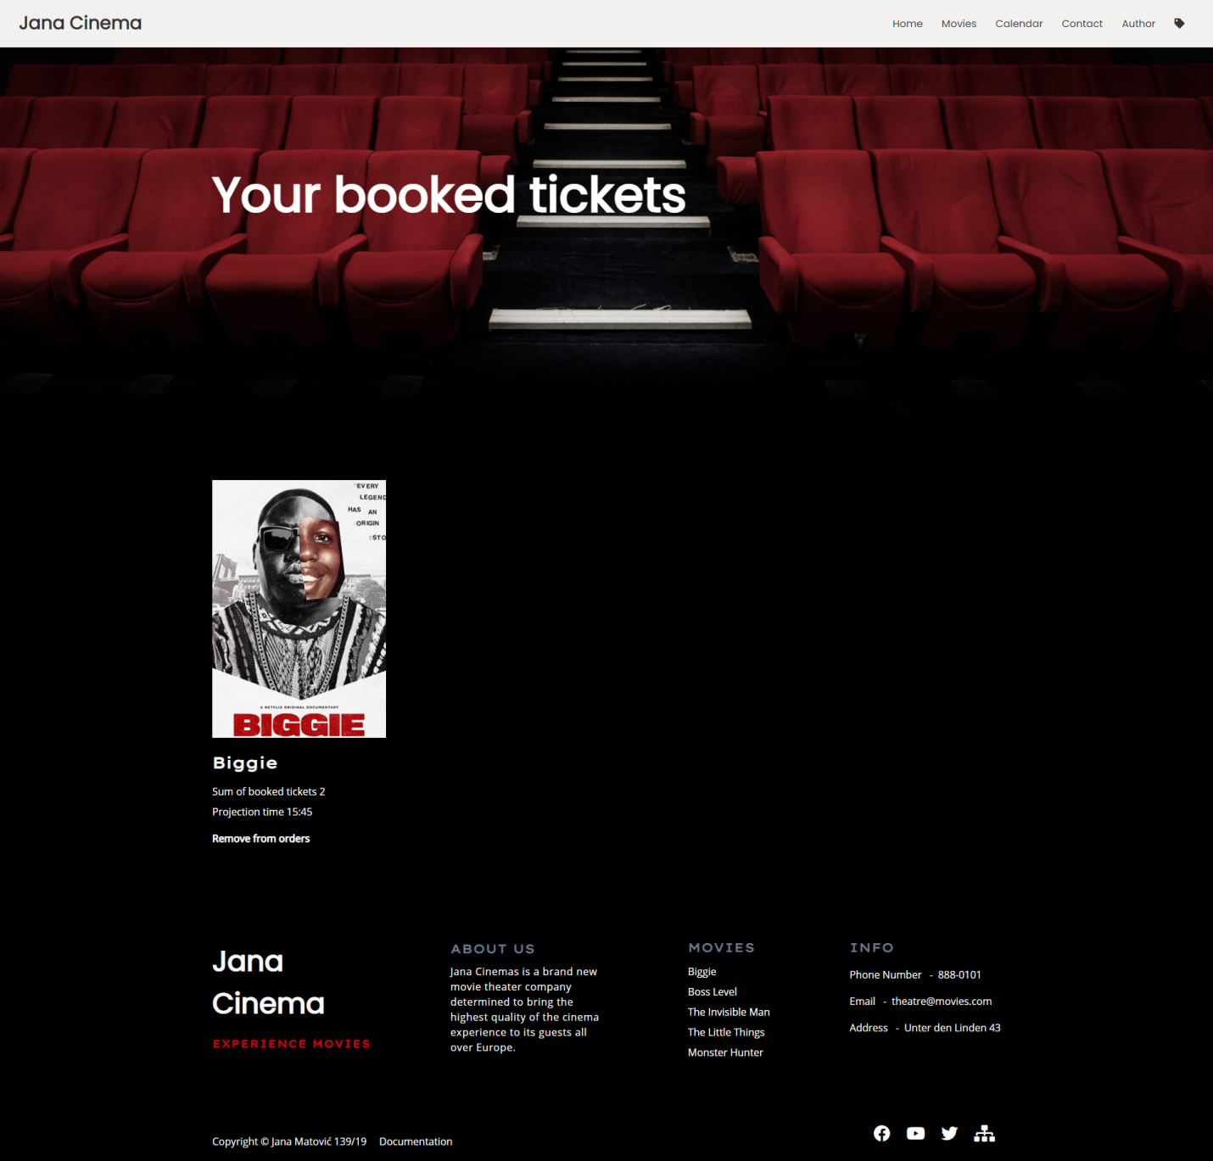

# 3.Kodovi

## 3.1 HTML

### 3.1.1 index.html

<!DOCTYPE html>

<html lang="en">

<head>

    <meta charset="UTF-8"/>

    <meta http-equiv="X-UA-Compatible" content="IE=edge"/>

    <meta name="viewport" content="width=2, initial-scale=1.0"/>

    <meta name="description" content="Jana Cinemas is a brand new movie theater company determined to bring the highest quality of the cinema experience to its guests all over Europe. Created as a partnership between a projector and a sound company, it uses cutting edge technology in achieving its goal."/>

    <meta name="keywords" content="Jana cinema, movies,cinema"/>

    <meta name="author" content="Jana Matović"/>

    <title>Jana Cinema</title>

    <link rel="stylesheet" href="assets/css/style.css" type="text/css"/>

    <link rel="stylesheet" href="https://cdnjs.cloudflare.com/ajax/libs/font-awesome/5.15.2/css/all.min.css" integrity="sha512-HK5fgLBL+xu6dm/Ii3z4xhlSUyZgTT9tuc/hSrtw6uzJOvgRr2a9jyxxT1ely+B+xFAmJKVSTbpM/CuL7qxO8w==" crossorigin="anonymous" />

    <link rel="preconnect" href="https://fonts.gstatic.com">

    <link href="https://fonts.googleapis.com/css2?family=Lexend+Mega&family=Open+Sans&family=Poppins&display=swap" rel="stylesheet"/>

    <link rel="icon" type="image/x-icon" href="assets/img/film-solid.svg"/>

</head>

<body>

    <nav>

        <div id="wrapperNav">

            <div id="logo"></div>

            <div id="links">

            </div>

            <div id="hamburger">

                <i class="fas fa-bars"></i>

            </div>

        </div>

    </nav>

    <header>

        <div id="naslov">

            <h1>Welcome to Jana Cinema</h1>

            <p>Experience Movies on a different level</p>

            <div id="dugme">

                <i class="fas fa-film"></i>

                <a href="calendar.html">Showtimes</a>

            </div>

        </div>

    </header>

    <main>

        <div id="about">

            <div id="tekst">

                <h2>All the perks</h2>

                <p>With us you have the exclusive opportunity to enjoy the newest movie releases in top-notch quality.</p>

            </div>

            <div id="opcije">

            </div>

        </div>

        <div id="komentari">

            <h2>Why Us</h2>

            <p class="podnaslov">Happy Viewers</p>

            <div id="blokoviKomentar">

            </div>

        </div>

        <div id="projekcija">

            <div id="slikaProjekcija">

                <img src="assets/img/invisible\_man.jpg" alt="Now In Cinema"/>

            </div>

            <div id="tekstProjekcija">

                <h2>Playing</h2>

                <h3>Now in Cinema</h3>

                <p>Here you can see what's currently playing in our cinemas, and what is soon to arrive!</p>

                <div id="dugme">

                    <i class="fas fa-film"></i>

                    <a href="movies.html">View All</a>

                </div>

            </div>

        </div>

    </main>

    <footer>

        <div id="wrapperFoo">

            <div id="gornjiFoo">

                <div class="logoFoo">

                    <h3>Jana <br/>Cinema</h3>

                    <p>Experience Movies</p>

                </div>

                <div class="aboutFoo">

                    <h4>About Us</h4>

                    <p>Jana Cinemas is a brand new movie theater company determined to bring the highest quality of the cinema experience to its guests all over Europe.</p>

                </div>

                <div class="latestMovies">

                    <h4>Movies</h4>

                    <div id="linksFoo">

                    </div>

                </div>

                <div class="kontaktInfoFoo">

                    <h4>Info</h4>

                    <div class="info">

                        <p>Phone Number &nbsp; - &nbsp;</p><a href="tel:052121"> 888-0101</a>

                    </div>

                    <div class="info">

                        <p>Email  &nbsp; - &nbsp; </p><a href="mailto:052121"> theatre@movies.com</a>

                    </div>

                    <div class="info">

                        <p>Address  &nbsp; - &nbsp; </p><a href="#">Unter den Linden 43</a>

                    </div>

                </div>

            </div>

            <div id="donjiFoo">

                <div id="leviBlok">

                    <p>Copyright &copy; Jana Matović 139/19</p>

                    <a href="documentation.pdf">Documentation</a>

                </div>

                <div id="desniBlok">

                    <a href=""><i class="fab fa-facebook"></i></a>

                    <a href=""><i class="fab fa-youtube"></i></a>

                    <a href=""><i class="fab fa-twitter"></i></a>

                    <a href="sitemap.xml"><i class="fas fa-sitemap"></i></a>

                </div>

            </div>

        </div>

    </footer>

    <script src="https://ajax.googleapis.com/ajax/libs/jquery/3.4.1/jquery.min.js"></script>

    <script src="assets/js/main.js" type="text/javascript"></script>

</body>

</html>

### 3.1.2 movies.html

<!DOCTYPE html>

<html lang="en">

<head>

    <meta charset="UTF-8"/>

    <meta http-equiv="X-UA-Compatible" content="IE=edge"/>

    <meta name="viewport" content="width=2, initial-scale=1.0"/>

    <meta name="description" content="Jana Cinemas is a brand new movie theater company determined to bring the highest quality of the cinema experience to its guests all over Europe. Created as a partnership between a projector and a sound company, it uses cutting edge technology in achieving its goal."/>

    <meta name="keywords" content="now playing, action,comedy,adventure,drama,tickets,horror"/>

    <meta name="author" content="Jana Matović"/>

    <title>Jana Cinema - Movie List</title>

    <link rel="stylesheet" href="assets/css/style.css" type="text/css"/>

    <link rel="stylesheet" href="https://cdnjs.cloudflare.com/ajax/libs/font-awesome/5.15.2/css/all.min.css" integrity="sha512-HK5fgLBL+xu6dm/Ii3z4xhlSUyZgTT9tuc/hSrtw6uzJOvgRr2a9jyxxT1ely+B+xFAmJKVSTbpM/CuL7qxO8w==" crossorigin="anonymous" />

    <link rel="preconnect" href="https://fonts.gstatic.com">

    <link href="https://fonts.googleapis.com/css2?family=Lexend+Mega&family=Open+Sans&family=Poppins&display=swap" rel="stylesheet"/>

    <link rel="icon" type="image/x-icon" href="assets/img/film-solid.svg"/>

</head>

<body>

    <nav>

        <div id="wrapperNav">

            <div id="logo"></div>

            <div id="links">

            </div>

            <div id="hamburger">

                <i class="fas fa-bars"></i>

            </div>

        </div>

    </nav>

    <header>

        <div id="naslov">

            <h1>Now Playing</h1>

            <p id="sortFilterTekst">Sort or filter movies so we can display them based on your wishes</p>

            <form action="#" method="POST" id="formaFilterSort">

                <div id="sortHtml">

                    <select id="sort">

                    </select>

                </div>

                <div id="filter">

                    <div id="pocetniPrikazFilter"><span>Choose Genre</span><i class="fas fa-arrow-down"></i></div>

                    <div id="zanrovi">

                    </div>

                </div>

            </form>

        </div>

    </header>

    <main>

        <div id="filmovi">

        </div>

    </main>

    <footer>

        <div id="wrapperFoo">

            <div id="gornjiFoo">

                <div class="logoFoo">

                    <h3>Jana <br/>Cinema</h3>

                    <p>Experience Movies</p>

                </div>

                <div class="aboutFoo">

                    <h4>About Us</h4>

                    <p>Jana Cinemas is a brand new movie theater company determined to bring the highest quality of the cinema experience to its guests all over Europe.</p>

                </div>

                <div class="latestMovies">

                    <h4>Movies</h4>

                    <div id="linksFoo">

                    </div>

                </div>

                <div class="kontaktInfoFoo">

                    <h4>Info</h4>

                    <div class="info">

                        <p>Phone Number &nbsp; - &nbsp;</p><a href="tel:052121"> 888-0101</a>

                    </div>

                    <div class="info">

                        <p>Email  &nbsp; - &nbsp; </p><a href="mailto:052121"> theatre@movies.com</a>

                    </div>

                    <div class="info">

                        <p>Address  &nbsp; - &nbsp; </p><a href="#">Unter den Linden 43</a>

                    </div>

                </div>

            </div>

            <div id="donjiFoo">

                <div id="leviBlok">

                    <p>Copyright &copy; Jana Matović 139/19</p>

                    <a href="documentation.pdf">Documentation</a>

                </div>

                <div id="desniBlok">

                    <a href=""><i class="fab fa-facebook"></i></a>

                    <a href=""><i class="fab fa-youtube"></i></a>

                    <a href=""><i class="fab fa-twitter"></i></a>

                    <a href="sitemap.xml"><i class="fas fa-sitemap"></i></a>

                </div>

            </div>

        </div>

    </footer>

    <div id="getTicket">

        <div id="getTicketBlock">

            <div id="gornjiGetTicket">

                <h2>Order Tickets Online</h2>

                <i class="far fa-times-circle"></i>

            </div>

            <div id="donjiGetTicket">

            </div>

        </div>

    </div>

    <script

  src="https://code.jquery.com/jquery-3.5.1.min.js"

  integrity="sha256-9/aliU8dGd2tb6OSsuzixeV4y/faTqgFtohetphbbj0="

  crossorigin="anonymous"></script>

    <script src="assets/js/main.js" type="text/javascript"></script>

</body>

</html>

### 3.1.3 calendar.html

<!DOCTYPE html>

<html lang="en">

<head>

    <meta charset="UTF-8"/>

    <meta http-equiv="X-UA-Compatible" content="IE=edge"/>

    <meta name="viewport" content="width=2, initial-scale=1.0"/>

    <meta name="description" content="Jana Cinemas is a brand new movie theater company determined to bring the highest quality of the cinema experience to its guests all over Europe. Created as a partnership between a projector and a sound company, it uses cutting edge technology in achieving its goal."/>

    <meta name="keywords" content="movie,movies,calendar,movie calendar"/>

    <meta name="author" content="Jana Matović"/>

    <title>Jana Cinema - Calendar</title>

    <link rel="stylesheet" href="assets/css/style.css" type="text/css"/>

    <link rel="stylesheet" href="https://cdnjs.cloudflare.com/ajax/libs/font-awesome/5.15.2/css/all.min.css" integrity="sha512-HK5fgLBL+xu6dm/Ii3z4xhlSUyZgTT9tuc/hSrtw6uzJOvgRr2a9jyxxT1ely+B+xFAmJKVSTbpM/CuL7qxO8w==" crossorigin="anonymous" />

    <link rel="preconnect" href="https://fonts.gstatic.com">

    <link href="https://fonts.googleapis.com/css2?family=Lexend+Mega&family=Open+Sans&family=Poppins&display=swap" rel="stylesheet"/>

    <link rel="icon" type="image/x-icon" href="assets/img/film-solid.svg"/>

</head>

<body>

    <nav>

        <div id="wrapperNav">

            <div id="logo"></div>

            <div id="links">

            </div>

            <div id="hamburger">

                <i class="fas fa-bars"></i>

            </div>

        </div>

    </nav>

    <header>

        <div id="naslov">

            <h1>Movie Calendar</h1>

        </div>

    </header>

    <main>

        <h2 id="podnaslov">These are the screenings of movies for <span id="podnaslovSpan"></span></h2>

        <div id="datumi">

        </div>

    </main>

    <footer>

        <div id="wrapperFoo">

            <div id="gornjiFoo">

                <div class="logoFoo">

                    <h3>Jana <br/>Cinema</h3>

                    <p>Experience Movies</p>

                </div>

                <div class="aboutFoo">

                    <h4>About Us</h4>

                    <p>Jana Cinemas is a brand new movie theater company determined to bring the highest quality of the cinema experience to its guests all over Europe.</p>

                </div>

                <div class="latestMovies">

                    <h4>Movies</h4>

                    <div id="linksFoo">

                    </div>

                </div>

                <div class="kontaktInfoFoo">

                    <h4>Info</h4>

                    <div class="info">

                        <p>Phone Number &nbsp; - &nbsp;</p><a href="tel:052121"> 888-0101</a>

                    </div>

                    <div class="info">

                        <p>Email  &nbsp; - &nbsp; </p><a href="mailto:052121"> theatre@movies.com</a>

                    </div>

                    <div class="info">

                        <p>Address  &nbsp; - &nbsp; </p><a href="#">Unter den Linden 43</a>

                    </div>

                </div>

            </div>

            <div id="donjiFoo">

                <div id="leviBlok">

                    <p>Copyright &copy; Jana Matović 139/19</p>

                    <a href="documentation.pdf">Documentation</a>

                </div>

                <div id="desniBlok">

                    <a href=""><i class="fab fa-facebook"></i></a>

                    <a href=""><i class="fab fa-youtube"></i></a>

                    <a href=""><i class="fab fa-twitter"></i></a>

                    <a href="sitemap.xml"><i class="fas fa-sitemap"></i></a>

                </div>

            </div>

        </div>

    </footer>

    <script

  src="https://code.jquery.com/jquery-3.5.1.min.js"

  integrity="sha256-9/aliU8dGd2tb6OSsuzixeV4y/faTqgFtohetphbbj0="

  crossorigin="anonymous"></script>

    <script src="assets/js/main.js" type="text/javascript"></script>

</body>

</html>

### 3.1.4 contact.html

<!DOCTYPE html>

<html lang="en">

<head>

    <meta charset="UTF-8"/>

    <meta http-equiv="X-UA-Compatible" content="IE=edge"/>

    <meta name="viewport" content="width=2, initial-scale=1.0"/>

    <meta name="description" content="Jana Cinemas is a brand new movie theater company determined to bring the highest quality of the cinema experience to its guests all over Europe. Created as a partnership between a projector and a sound company, it uses cutting edge technology in achieving its goal."/>

    <meta name="keywords" content="contact,message"/>

    <meta name="author" content="Jana Matović"/>

    <title>Jana Cinema - Contact</title>

    <link rel="stylesheet" href="assets/css/style.css" type="text/css"/>

    <link rel="stylesheet" href="https://cdnjs.cloudflare.com/ajax/libs/font-awesome/5.15.2/css/all.min.css" integrity="sha512-HK5fgLBL+xu6dm/Ii3z4xhlSUyZgTT9tuc/hSrtw6uzJOvgRr2a9jyxxT1ely+B+xFAmJKVSTbpM/CuL7qxO8w==" crossorigin="anonymous" />

    <link rel="preconnect" href="https://fonts.gstatic.com">

    <link href="https://fonts.googleapis.com/css2?family=Lexend+Mega&family=Open+Sans&family=Poppins&display=swap" rel="stylesheet"/>

    <link rel="icon" type="image/x-icon" href="assets/img/film-solid.svg"/>

</head>

<body>

    <nav>

        <div id="wrapperNav">

            <div id="logo"></div>

            <div id="links">

            </div>

            <div id="hamburger">

                <i class="fas fa-bars"></i>

            </div>

        </div>

    </nav>

    <header>

        <div id="naslov">

            <h1>Contact Us</h1>

            <div id="contactInfoBlock">

                <div class="contactInfo">

                    <h3>Phone</h3>

                    <a href="tel:111">

                        888-0101</a>

                </div>

                <div class="contactInfo">

                    <h3>Address</h3>

                    <a href="https://goo.gl/maps/XMEQLj2FBGiPEshU7">Unter den Linden 43</a>

                </div>

                <div class="contactInfo">

                    <h3>Email</h3>

                    <a href="mailto:theatre@movies.com">theatre@movies.com</a>

                </div>

            </div>

        </div>

        <div id="contact">

            <div id="forma">

                <h2>Send us a message</h2>

                <form action="#" method="POST" id="kontaktForma">

                    <div class='group'>

                        <input type="text" name="ime" id="ime" placeholder="Name"/>

                        <p class='err'></p>

                    </div>

                    <div class='group'>

                        <input type="email" name="email" id="email" placeholder="Email Address"/>

                        <p class='err'></p>

                    </div>

                    <div class='group'>

                        <textarea id="poruka" name="poruka" placeholder="Message"></textarea>

                        <p class='err'></p>

                    </div>

                    <input type="submit" name="submit" id="submit" value="Submit"/>

                </form>

            </div>

        </div>

    </header>

    <main>

        <div id="mapa">

            <iframe src="https://www.google.com/maps/embed?pb=!1m18!1m12!1m3!1d2427.9314824265803!2d13.384324115953126!3d52.51657904423496!2m3!1f0!2f0!3f0!3m2!1i1024!2i768!4f13.1!3m3!1m2!1s0x47a851c494835237%3A0x5cb479c27f53e5c6!2zVW50ZXIgZGVuIExpbmRlbiA0MywgMTAxMTcgQmVybGluLCDQndC10LzQsNGH0LrQsA!5e0!3m2!1ssr!2srs!4v1614987080625!5m2!1ssr!2srs"  style="border:0;" allowfullscreen="" loading="lazy"></iframe>

        </div>

    </main>

    <footer>

        <div id="wrapperFoo">

            <div id="gornjiFoo">

                <div class="logoFoo">

                    <h3>Jana <br/>Cinema</h3>

                    <p>Experience Movies</p>

                </div>

                <div class="aboutFoo">

                    <h4>About Us</h4>

                    <p>Jana Cinemas is a brand new movie theater company determined to bring the highest quality of the cinema experience to its guests all over Europe.</p>

                </div>

                <div class="latestMovies">

                    <h4>Movies</h4>

                    <div id="linksFoo">

                    </div>

                </div>

                <div class="kontaktInfoFoo">

                    <h4>Info</h4>

                    <div class="info">

                        <p>Phone Number &nbsp; - &nbsp;</p><a href="tel:052121"> 888-0101</a>

                    </div>

                    <div class="info">

                        <p>Email  &nbsp; - &nbsp; </p><a href="mailto:052121"> theatre@movies.com</a>

                    </div>

                    <div class="info">

                        <p>Address  &nbsp; - &nbsp; </p><a href="#">Unter den Linden 43</a>

                    </div>

                </div>

            </div>

            <div id="donjiFoo">

                <div id="leviBlok">

                    <p>Copyright &copy; Jana Matović 139/19</p>

                    <a href="documentation.pdf">Documentation</a>

                </div>

                <div id="desniBlok">

                    <a href=""><i class="fab fa-facebook"></i></a>

                    <a href=""><i class="fab fa-youtube"></i></a>

                    <a href=""><i class="fab fa-twitter"></i></a>

                    <a href="sitemap.xml"><i class="fas fa-sitemap"></i></a>

                </div>

            </div>

        </div>

    </footer>

    <script

  src="https://code.jquery.com/jquery-3.5.1.min.js"

  integrity="sha256-9/aliU8dGd2tb6OSsuzixeV4y/faTqgFtohetphbbj0="

  crossorigin="anonymous"></script>

    <script src="assets/js/main.js" type="text/javascript"></script>

</body>

</html>

### 3.1.5 author.html

<!DOCTYPE html>

<html lang="en">

<head>

    <meta charset="UTF-8"/>

    <meta http-equiv="X-UA-Compatible" content="IE=edge"/>

    <meta name="viewport" content="width=2, initial-scale=1.0"/>

    <meta name="description" content="Jana Cinemas is a brand new movie theater company determined to bring the highest quality of the cinema experience to its guests all over Europe. Created as a partnership between a projector and a sound company, it uses cutting edge technology in achieving its goal."/>

    <meta name="keywords" content="author,jana,jana matović"/>

    <meta name="author" content="Jana Matović"/>

    <title>Jana Cinema - Author</title>

    <link rel="stylesheet" href="assets/css/style.css" type="text/css"/>

    <link rel="stylesheet" href="https://cdnjs.cloudflare.com/ajax/libs/font-awesome/5.15.2/css/all.min.css" integrity="sha512-HK5fgLBL+xu6dm/Ii3z4xhlSUyZgTT9tuc/hSrtw6uzJOvgRr2a9jyxxT1ely+B+xFAmJKVSTbpM/CuL7qxO8w==" crossorigin="anonymous" />

    <link rel="preconnect" href="https://fonts.gstatic.com">

    <link href="https://fonts.googleapis.com/css2?family=Lexend+Mega&family=Open+Sans&family=Poppins&display=swap" rel="stylesheet"/>

    <link rel="icon" type="image/x-icon" href="assets/img/film-solid.svg"/>

</head>

<body>

    <nav>

        <div id="wrapperNav">

            <div id="logo"></div>

            <div id="links">

            </div>

            <div id="hamburger">

                <i class="fas fa-bars"></i>

            </div>

        </div>

    </nav>

    <header>

        <div id="naslov">

            <h1>Author</h1>

        </div>

    </header>

    <main>

        <div id="autor">

            <div id="slikaAutor">

                <img src="assets/img/author.jpg" alt="Jana Matovic 139/19"/>

            </div>

            <div id="tekstAutor">

                <div class="infoAutor">

                    <h2>Info</h2>

                    <p>Jana Matović 139/19</p>

                    <p>Smer- Internet tehnologije </p>

                    <p> Modul- Web programiranje</p>

                </div>

                <div class="aboutAutor">

                    <p>Zovem se Jana Matović i rođena sam u Prijepolju.</p>

                    <p>Završila sam Prijepoljsku gimnaziju, prirodno - matematički smer.</p>

                    <p>Oduvek sam bila odusevljena računarima, pa sam zbog toga i upisala programiranje. </p>

                    <p> Pored maternjeg jezika, znam engleski i malo nemački.</p>

                </div>

            </div>

        </div>

    </main>

    <footer>

        <div id="wrapperFoo">

            <div id="gornjiFoo">

                <div class="logoFoo">

                    <h3>Jana <br/>Cinema</h3>

                    <p>Experience Movies</p>

                </div>

                <div class="aboutFoo">

                    <h4>About Us</h4>

                    <p>Jana Cinemas is a brand new movie theater company determined to bring the highest quality of the cinema experience to its guests all over Europe.</p>

                </div>

                <div class="latestMovies">

                    <h4>Movies</h4>

                    <div id="linksFoo">

                    </div>

                </div>

                <div class="kontaktInfoFoo">

                    <h4>Info</h4>

                    <div class="info">

                        <p>Phone Number &nbsp; - &nbsp;</p><a href="tel:052121"> 888-0101</a>

                    </div>

                    <div class="info">

                        <p>Email  &nbsp; - &nbsp; </p><a href="mailto:052121"> theatre@movies.com</a>

                    </div>

                    <div class="info">

                        <p>Address  &nbsp; - &nbsp; </p><a href="#">Unter den Linden 43</a>

                    </div>

                </div>

            </div>

            <div id="donjiFoo">

                <div id="leviBlok">

                    <p>Copyright &copy; Jana Matović 139/19</p>

                    <a href="documentation.pdf">Documentation</a>

                </div>

                <div id="desniBlok">

                    <a href=""><i class="fab fa-facebook"></i></a>

                    <a href=""><i class="fab fa-youtube"></i></a>

                    <a href=""><i class="fab fa-twitter"></i></a>

                    <a href="sitemap.xml"><i class="fas fa-sitemap"></i></a>

                </div>

            </div>

        </div>

    </footer>

    <script

  src="https://code.jquery.com/jquery-3.5.1.min.js"

  integrity="sha256-9/aliU8dGd2tb6OSsuzixeV4y/faTqgFtohetphbbj0="

  crossorigin="anonymous"></script>

    <script src="assets/js/main.js" type="text/javascript"></script>

</body>

</html>

### 3.1.6 orders.html

<!DOCTYPE html>

<html lang="en">

<head>

    <meta charset="UTF-8"/>

    <meta http-equiv="X-UA-Compatible" content="IE=edge"/>

    <meta name="viewport" content="width=2, initial-scale=1.0"/>

    <meta name="description" content="Jana Cinemas is a brand new movie theater company determined to bring the highest quality of the cinema experience to its guests all over Europe. Created as a partnership between a projector and a sound company, it uses cutting edge technology in achieving its goal."/>

    <meta name="keywords" content="booked tickets, tickets, booked"/>

    <meta name="author" content="Jana Matović"/>

    <title>Jana Cinema - Orders List</title>

    <link rel="stylesheet" href="assets/css/style.css" type="text/css"/>

    <link rel="stylesheet" href="https://cdnjs.cloudflare.com/ajax/libs/font-awesome/5.15.2/css/all.min.css" integrity="sha512-HK5fgLBL+xu6dm/Ii3z4xhlSUyZgTT9tuc/hSrtw6uzJOvgRr2a9jyxxT1ely+B+xFAmJKVSTbpM/CuL7qxO8w==" crossorigin="anonymous" />

    <link rel="preconnect" href="https://fonts.gstatic.com">

    <link href="https://fonts.googleapis.com/css2?family=Lexend+Mega&family=Open+Sans&family=Poppins&display=swap" rel="stylesheet"/>

    <link rel="icon" type="image/x-icon" href="assets/img/film-solid.svg"/>

</head>

<body>

    <nav>

        <div id="wrapperNav">

            <div id="logo"></div>

            <div id="links">

            </div>

            <div id="hamburger">

                <i class="fas fa-bars"></i>

            </div>

        </div>

    </nav>

    <header>

        <div id="naslov">

            <h1>Your booked tickets</h1>

        </div>

    </header>

    <main>

        <div id="orders">

        </div>

    </main>

    <footer>

        <div id="wrapperFoo">

            <div id="gornjiFoo">

                <div class="logoFoo">

                    <h3>Jana <br/>Cinema</h3>

                    <p>Experience Movies</p>

                </div>

                <div class="aboutFoo">

                    <h4>About Us</h4>

                    <p>Jana Cinemas is a brand new movie theater company determined to bring the highest quality of the cinema experience to its guests all over Europe.</p>

                </div>

                <div class="latestMovies">

                    <h4>Movies</h4>

                    <div id="linksFoo">

                    </div>

                </div>

                <div class="kontaktInfoFoo">

                    <h4>Info</h4>

                    <div class="info">

                        <p>Phone Number &nbsp; - &nbsp;</p><a href="tel:052121"> 888-0101</a>

                    </div>

                    <div class="info">

                        <p>Email  &nbsp; - &nbsp; </p><a href="mailto:052121"> theatre@movies.com</a>

                    </div>

                    <div class="info">

                        <p>Address  &nbsp; - &nbsp; </p><a href="#">Unter den Linden 43</a>

                    </div>

                </div>

            </div>

            <div id="donjiFoo">

                <div id="leviBlok">

                    <p>Copyright &copy; Jana Matović 139/19</p>

                    <a href="documentation.pdf">Documentation</a>

                </div>

                <div id="desniBlok">

                    <a href=""><i class="fab fa-facebook"></i></a>

                    <a href=""><i class="fab fa-youtube"></i></a>

                    <a href=""><i class="fab fa-twitter"></i></a>

                    <a href="sitemap.xml"><i class="fas fa-sitemap"></i></a>

                </div>

            </div>

        </div>

    </footer>

    <script src="https://ajax.googleapis.com/ajax/libs/jquery/3.4.1/jquery.min.js"></script>

    <script src="assets/js/main.js" type="text/javascript"></script>

</body>

</html>

## 3.2 CSS

### 3.2.1 style.css

\*{

    padding:0px;

    margin:0px;

}

a{

    text-decoration: none;

    color:#fff;

}

p,label,textarea,input{

    font-family: 'Open Sans', sans-serif;

}

h2,h3{

    font-family: 'Lexend Mega', sans-serif;

}

/\* NAV \*/

nav{

   width:100%;

    z-index: 100;

   background:#F2F1EF;

   padding:15px 0px;

   position:fixed;

   top:0px;

   font-family: 'Poppins', sans-serif;

}

 #wrapperNav{

    display: flex;

    justify-content: space-between;

    margin:0px 30px;

}

 nav #logo a{

    font-size:1.8em;

    font-weight: 600;

    color:#333;

}

 nav #links{

    margin:10px 0px;

    transition: .3s ease;

}

nav #hamburger{

    display:none;

}

 nav #links a{

    margin:0px 15px;

    font-size:1em;

    text-decoration: none;

    color: #333;

    font-weight: 500;

    transition: .3s ease;

}

 nav #links a:hover{

    color:#6C7A89;

}

nav #links .active{

    font-weight: 600;

}

/\* HEADER \*/

header{

    min-height:75vh;

    background-image: url('../img/heaader.jpg');

    background-size: cover;

    background-position: bottom;

}

header #naslov{

    color:#fff;

    width:65%;

    margin:0px auto;

    padding-top:250px;

    /\* margin:auto auto; \*/

    font-family: 'Poppins', sans-serif;

}

header #naslov h1{

    font-size:4.8em;

    margin-bottom: 20px;

}

header #naslov #sortFilterTekst{

    font-size:1.5em;

    color:#fff;

}

header #naslov p{

    font-size:1.5em;

    color:#fff;

    padding-bottom: 25px;

}

header #naslov #dugme, main #projekcija #tekstProjekcija #dugme{

    text-decoration: none;

    padding:15px;

    width:150px;

    background-color: #CF000F;

    text-align: center;

    color:#fff;

    border-radius: 5px;

}

header #naslov #dugme i,main #projekcija #tekstProjekcija #dugme i{

    margin-right: 5px;

}

header #naslov #dugme a,main #projekcija #tekstProjekcija #dugme a{

    color:#fff;

    text-decoration: none;

}

/\* MAIN \*/

main{

    color:#fff;

}

main #about{

    width:65%;

    padding-top: 100px;

    margin:0px auto;

    display: flex;

    justify-content: space-between;

}

main #about #tekst{

    width:30%;

}

main #about #tekst h2{

    font-size:4em;

    font-family: 'Lexend Mega', sans-serif;

    margin-bottom: 50px;

}

main #about #tekst p{

    line-height: 1.8;

}

main #about #opcije{

    border:1px solid #CF000F;

    padding:50px;

    width: 50%;

   text-align: left;

    border-radius: 2px;

}

main #about #opcije .opcija{

    padding:20px 10px;

    width:45%;

    float: left;

}

main #about #opcije h3{

    font-family: 'Poppins', sans-serif;

    margin-bottom: 10px;

    letter-spacing: 1px;

}

main #about #opcije .opcija p{

    text-align: left;

    line-height: 1.5;

}

main #komentari{

    width:65%;

    margin:0px auto;

    margin-top:100px;

}

main #komentari h2{

    font-size:2.5em;

    text-align: center;

}

main #komentari .podnaslov{

    margin-top:20px;

    color:#CF000F;

    letter-spacing: 2px;

    text-transform: uppercase;

    text-align: center;

    font-weight: 600;

}

main #komentari #blokoviKomentar {

    display:flex;

    justify-content: space-between;

}

main #komentari #blokoviKomentar .blokKomentar{

    margin-top:50px;

    height:300px;

    width:30%;

    border:1px solid #fff;

    position:relative;

}

main #komentari #blokoviKomentar .blokKomentar p{

    font-size:1em;

    line-height: 1.6;

    width:75%;

    font-style: italic;

    position:absolute;

    top:50%;

    left:50%;

    transform: translate(-50%,-50%);

}

main #komentari #blokoviKomentar .blokKomentar p span:first-of-type{

    margin-right: 10px;

}

main #komentari #blokoviKomentar .blokKomentar p span:last-child{

    margin-left: 10px;

}

main #projekcija{

    width:65%;

    /\* margin:200px auto; \*/

    margin:0px auto;

    padding:100px 0px;

    display:flex;

}

main #projekcija #slikaProjekcija img{

    width:60%;

}

main #projekcija #tekstProjekcija h2{

    font-size:1.3em;

    color:#CF000F;

    margin-bottom: 20px;

    font-family: 'Lexend Mega', sans-serif;

}

main #projekcija #tekstProjekcija h3{

    font-size:3em;

    margin-bottom: 50px;

}

main #projekcija #tekstProjekcija p{

    width:90%;

    margin-bottom: 50px;

    line-height: 1.8;

}

main #projekcija #tekstProjekcija a{

    font-family: 'Poppins', sans-serif;

}

main,footer{

    background-color: #000;

}

/\* MOVIES \*/

#formaFilterSort{

    display: flex;

}

#formaFilterSort #sort{

    width:200px;

    height:36px;

    margin-right: 50px;

   font-size:1em;

}

#formaFilterSort #sort option{

    padding:20px 0px;

}

#formaFilterSort #filter #pocetniPrikazFilter{

    height:31px;

    background-color: #fff;

    color:#000;

    padding:5px 5px 0px 5px;

    display: flex;

    justify-content: space-between;

    width:200px;

}

#formaFilterSort #filter #pocetniPrikazFilter i{

    padding-top:6px;

    font-size:.75em;

}

#formaFilterSort #filter{

    width:200px;

}

#zanrovi{

    padding:10px 10px;

    display:none;

    background:#fff;

    color:#333;

    width:190px

}

#zanrovi input{

    margin-bottom: 10px;

    margin-right: 10px;

}

.prikazZanr{

    display:block!important;

}

main #filmovi{

    width:65%;

    margin:0px auto;

    padding:100px 0px;

    display: flex;

    flex-wrap: wrap;

    justify-content: space-between;

}

#filmovi .film{

    width:22%;

    margin-bottom: 50px;

}

#filmovi .film:nth-child(4){

    flex-wrap: after;

}

#filmovi .film img{

    width:100%;

}

#filmovi .film h2{

    min-height:40px;

    margin: 20px 0px;

    font-size:1.4em;

}

#filmovi .film .genre{

    display: flex;

    flex-wrap: wrap;

    margin-bottom: 10px;

}

#filmovi .film .genre p{

    background:rgba(207, 0, 15,0.7);

    text-align: center;

    border-radius: 2px;

    padding:10px 15px;

    margin-bottom: 10px;

    margin-right: 10px;

     height:20px;

     border-radius: 50px;

}

#filmovi .film p{

    margin-bottom: 5px;

    font-size:.9em;

}

#filmovi .film p:nth-of-type(2){

   margin-bottom: 30px;

}

#filmovi .film a{

    border:1px solid #CF000F;

    padding:10px 20px;

    text-decoration: none;

    color:#fff;

    text-align: center;

    font-family: 'Poppins', sans-serif;

    text-transform: uppercase;

    transition: .3s ease;

    border-radius: 50px;

}

#filmovi .film a:hover{

    background-color: #CF000F;

}

/\* CALENDAR \*/

main #podnaslov{

    width: 65%;

    margin:0px auto;

}

main #datumi{

    width:65%;

    margin:0px auto;

    padding:100px 0px;

    display: flex;

    flex-wrap: wrap;

}

main #datumi .datum{

    padding-bottom: 20px;

    width:30%;

}

main #datumi .datum h2{

    margin-bottom: 50px;

    font-size:2.5em;

}

main #datumi .datum .projekcijaFilmova{

    display: flex;

    flex-wrap: wrap;

}

main #datumi .datum .filmProjekcija{

    margin-bottom: 30px;

    margin-right: 50px;

    width:80%!important;

    position:relative;

    padding-left: 20px;

}

.linija{

    height:100%;

    width:4px;

    background-color: #CF000F;

    position:absolute;

    left:0px;

}

main #datumi .datum .filmProjekcija .vremePrikaz{

    display: flex;

    margin-top:15px;

}

main #datumi .datum .filmProjekcija .vremePrikaz p{

    margin-right: 10px;

}

/\* AUTHOR \*/

#autor{

    width:65%;

    margin:0px auto;

    display: flex;

    justify-content: space-between;

    padding:100px 0px;

}

#autor #slikaAutor{

    width: 30%;

}

#autor #slikaAutor img{

    width: 100%;

}

#autor #tekstAutor .infoAutor{

    margin-bottom: 50px;

}

#autor #tekstAutor .infoAutor h2{

    font-size:2.5em;

    margin-bottom: 50px;

}

#autor #tekstAutor{

    line-height:1.8;

}

/\* CONTACT \*/

#contactInfoBlock{

    margin-top:50px;

    width:50%;

    display: flex;

    flex-wrap: wrap;

}

#contactInfoBlock .contactInfo{

    width: 45%;

    margin-bottom: 20px;

}

#contactInfoBlock .contactInfo h3{

    text-transform: uppercase;

    margin-bottom: 10px;

    color:#19B5FE;

}

#contactInfoBlock .contactInfo a{

    font-size:1.25em;

}

#contact{

    margin:0px auto;

    padding:100px 0px;

    width:65%;

    display: flex;

    justify-content: space-between;

}

#contact #forma{

    width:50%;

}

#contact #forma h2{

    margin-bottom: 50px;

    color: #fff;

}

#contact #forma form{

    width:75%;

    display: flex;

    flex-direction: column;

}

#contact #forma form .err{

    color:#fff;

    margin-top:10px;

    margin-bottom: 20px;

    letter-spacing: .6px;

}

#contact #forma form input{

    height:42px;

    padding-left: 10px;

  width:100%;

    background-color: rgb(17,17,17);

    border:0px;

    color:#fff;

    border-radius: 3px;

}

#contact #forma form textarea{

    width:100%;

    height:150px;

    resize: none;

    border:0px;

    background-color: rgb(17,17,17);

    border-radius: 3px;

    padding:10px;

    color:#fff;

    font-size:1em;

    margin-bottom:0px;

}

#contact #forma form input[type="submit"]{

    background-color: rgb(207, 0, 15);

    height:44px;

    width:105%;

}

 #mapa {

    width: 100%;

    height:350px;

    border:0px;

    padding-bottom: 100px;

}

#mapa iframe{

    width: 100%;

    height:100%;

    border:0px;

}

/\* TICKETS \*/

#karte{

    width:65%;

    margin:0px auto;

    height:100vh;

    padding:100px 0px;

}

#karte h2{

    font-size:1.5em;

    margin-bottom: 20px;

}

#bioskop {

    display: flex;

    margin:0px auto;

}

#bioskop .kolona:nth-of-type(2){

    margin:0px 20px;

}

#bioskop .kolona .red{

    display: flex;

}

#bioskop .kolona .red .sediste{

    margin-right: 10px;

    height:20px;

    width:20px;

    background-color: #fff;

    margin-bottom: 10px;

    border-radius: 1px;

}

/\* FOOTER \*/

footer{

    width:100%;

    color:#fafafa;

    position:relative;

}

footer #wrapperFoo{

    width: 65%;

    min-height:350px;

    margin:0px auto;

}

footer #gornjiFoo{

    height:90%;

    display:flex;

    justify-content: space-between;

}

footer #gornjiFoo h4{

    font-size:1.2em;

    text-transform: uppercase;

    letter-spacing: 1px;

    margin-bottom: 10px;

    color:#6C7A89;

    font-family: 'Lexend Mega', sans-serif;

}

footer #gornjiFoo .logoFoo h3{

    font-size:2.8em;

    padding-bottom: 20px;

    font-family: 'Poppins', sans-serif;

}

footer #gornjiFoo .logoFoo p{

    font-size:1em;

    font-weight: 600;

    text-transform: uppercase;

    letter-spacing: 1.5px;

    font-family: 'Lexend Mega', sans-serif;

    color:#CF000F;

}

footer #gornjiFoo .aboutFoo{

    width:250px;

    line-height:1.5;

    letter-spacing: .7px;

    font-family: 'Open Sans', sans-serif;

}

footer #gornjiFoo #linksFoo{

    display: flex;

    flex-direction: column;

}

footer #gornjiFoo .latestMovies #linksFoo{

    display: flex;

    flex-direction: column;

}

footer #gornjiFoo .latestMovies #linksFoo a{

    padding:5px 0px;

    font-family: 'Open Sans', sans-serif;

    color:#fff;

}

footer #gornjiFoo .kontaktInfoFoo .info{

    display:flex;

    padding:10px 0px;

    font-size:1em;

    font-family: 'Open Sans', sans-serif;

}

footer #gornjiFoo .kontaktInfoFoo .info a{

    color:#fafafa;

}

footer #donjiFoo{

    /\* height:10%; \*/

    display:flex;

    position:absolute;

    bottom:20px;

    width:65%;

    justify-content: space-between;

}

footer #donjiFoo #leviBlok{

    padding-top:15px;

    position:relative;

    left:0px;

    font-family: 'Open Sans', sans-serif;

    display: flex;

}

footer #donjiFoo #leviBlok a{

    margin-left:20px;

}

footer #donjiFoo #desniBlok{

    font-size:1.6em;

    position:relative;

    left:0px;

}

footer #donjiFoo #desniBlok i{

    padding:0px 10px;

}

#getTicket{

    background:rgba(0,0,0,0.9);

    height:100vh;

    width:100vw;

    display: none;

    position:fixed;

    top:0px;

}

#getTicket #getTicketBlock{

    width: 25%;

    height:50%;

    background:#fff;

    position:absolute;

    top:50%;

    left:50%;

    transform:translate(-50%,-50%);

    padding:50px;

}

#getTicket #getTicketBlock #gornjiGetTicket{

    display: flex;

    justify-content: space-between;

    margin-bottom: 50px;

}

#getTicket #getTicketBlock #gornjiGetTicket i{

    font-size:1.5em;

}

#formaGetTicket .form-group{

    display: flex;

    flex-direction: column;

    padding-bottom: 15px;

}

#formaGetTicket .form-group label{

    margin-bottom: 10px;

    font-size: 1.2em;

    font-weight: 600;

}

.form-group input,.form-group select{

    height:36px;

    padding-left: 5px;

    border-radius: 5px;

    border:0px;

    background:rgb(122, 95, 95);

    color:#fff;

}

#submitTicket{

    height:40px;

    border:0px;

    width:100%;

    margin-top:10px;

    background:#CF000F;

    color:#fff;

    border-radius: 5px;

}

/\* Orders \*/

main #orders{

    width:65%;

    margin:0px auto;

    padding:100px 0px;

    display: flex;

    justify-content:space-between;

    flex-wrap: wrap;

}

main #orders .prazanLs p{

    line-height: 2;

}

main #orders .filmBooked{

    width:22%;

    margin-bottom: 50px;

}

main #orders .filmBooked img{

    width:100%;

    margin-bottom: 20px;

}

main #orders .filmBooked p:nth-of-type(1){

    margin-bottom: 10px;

   margin-top:20px;

}

main #orders .filmBooked p:nth-of-type(3){

    margin-top:20px;

    font-weight: 600;

 }

main #orders .filmBooked img{

    width:100%;

    margin-bottom: 20px;

}

@media screen and (max-width:1440px){

    header #naslov{

        padding-top:200px;

    }

    header #naslov h1 {

        font-size: 4em;

    }

    header #naslov p {

        font-size: 1.3em;

    }

    footer #gornjiFoo .aboutFoo {

        width: 200px;

        font-size: .95em;

    }

    footer #gornjiFoo .logoFoo p {

        font-size: .9em;

        letter-spacing: 1px;

    }

    footer #donjiFoo #desniBlok {

        font-size: 1.3em;

    }

    #filmovi .film {

        width: 30%;

    }

    main #datumi .datum .filmProjekcija {

        width:15%;

    }

    #getTicket #getTicketBlock {

        width: 35%;

    }

    #autor #tekstAutor {

       width:50%;

    }

}

@media screen and (max-width:1280px){

    header #naslov{

        padding-top:150px;

    }

    header #naslov, main #about,main #komentari, main #projekcija,footer #wrapperFoo,main #filmovi,main #datumi,#contact,footer #donjiFoo,main #orders

    {

        width:75%;

    }

    header #naslov #dugme, main #projekcija #tekstProjekcija #dugme {

        width: 120px;

    }

    main #about #tekst h2 {

        font-size: 3em;

    }

    main #orders .filmBooked {

        width: 29%;

        margin-bottom: 50px;

    }

}

@media screen and (max-width:1024px){

    @keyframes navAnimacija{

        from{

            left:-1000px;

        }

        to{

            left:0px;

        }

    }

    #filmovi .film h2{

        min-height:50px;

        font-size:1.2em;

    }

    nav #hamburger{

        display:block;

    }

    nav #hamburger i{

        font-size:1.5em;

        margin-top:3px;

    }

    nav #links{

        display:none;

        position:absolute;

        top:50px;

        left:0px;

        width:100%;

        background:#F2F1EF;

        flex-direction: column;

        padding:20px;

    }

    nav #links a{

        padding:10px 0px;

    }

    .otvoriNav{

        display:flex!important;

        animation:navAnimacija .5s;

    }

    header {

        min-height: 50vh;

    }

    main #about{

        flex-wrap: wrap;

    }

    main #about #tekst {

        width: 100%;

    }

    main #about #opcije {

        margin-top:50px;

        width: 100%;

    }

    footer #gornjiFoo {

       flex-direction: column;

    }

    footer #gornjiFoo .aboutFoo{

        margin:50px 0px;

    }

    footer #gornjiFoo .kontaktInfoFoo{

        margin:50px 0px;

    }

    #contactInfoBlock {

        width: 75%;

    }

    #contact #forma {

        width: 100%;

    }

}

@media screen and (max-width:768px){

    #autor{

        flex-wrap: wrap;

    }

    #autor #slikaAutor {

        width: 50%;

    }

    #autor #tekstAutor {

        width: 100%;

    }

    main #datumi .datum {

        padding-bottom: 20px;

        width: 45%;

    }

    header #naslov #sortFilterTekst {

        font-size: 1.2em;

        color: #fff;

    }

    #getTicket #getTicketBlock {

        width: 50%;

    }

    main #komentari #blokoviKomentar .blokKomentar p {

        font-size: .9em;

        line-height: 1.5;

        width: 75%;

    }

}

@media screen and (max-width:540px){

    header #naslov h1 {

        font-size: 3em;

    }

    header #naslov p {

        font-size: 1.1em;

    }

    header #naslov #dugme, main #projekcija #tekstProjekcija #dugme {

        padding: 10px;

    }

    main #about #tekst h2 {

        font-size: 2.2em;

    }

    main #about #tekst p {

        line-height: 1.8;

        width:80%;

    }

    main #about #opcije .opcija {

        padding: 10px 5px;

        width: 100%;

    }

    main #komentari{

        width: 95%;

    }

    main #komentari #blokoviKomentar .blokKomentar p {

        font-size: .85em;

    }

    main #projekcija #tekstProjekcija h3 {

        font-size: 2.2em;

        margin-bottom: 50px;

    }

    main #projekcija #tekstProjekcija p {

        width: 90%;

        margin-bottom: 30px;

        line-height: 1.6;

        font-size:.95em;

    }

    main #about #opcije {

        padding: 30px;

    }

    footer #donjiFoo {

        flex-direction: column;

        flex-direction: column-reverse;

        position: static;

    }

    nav #hamburger i {

        font-size: 1.3em;

        margin-top: 5px;

    }

    #formaFilterSort #sort {

        width: 150px;

       margin-right: 20px;

    }

    #formaFilterSort #filter #pocetniPrikazFilter{

        width: 150px;

    }

    #zanrovi{

        width:140px;

    }

    #filmovi .film {

        width: 45%;

    }

    #filmovi .film .genre {

        min-height:60px;

    }

    #filmovi .film .genre p{

        font-size:.85em;

        padding:10px;

    }

    #getTicket #getTicketBlock {

        width: 70%;

    }

    #getTicket #getTicketBlock #gornjiGetTicket {

        margin-bottom: 20px;

    }

    #getTicket #getTicketBlock #gornjiGetTicket h2{

        font-size:1.2em;

    }

    main #datumi .datum .filmProjekcija {

        width: 30%;

    }

    #contactInfoBlock {

        width: 100%;

    }

    #contactInfoBlock .contactInfo h3 {

        font-size:1.2em;

    }

    #contactInfoBlock .contactInfo a {

        font-size: 1em;

    }

    main #datumi .datum {

        padding-bottom: 20px;

        width: 47%;

    }

    main #orders .filmBooked {

        width: 45%;

        margin-bottom: 50px;

    }

}

@media screen and (max-width:414px){

    main #datumi .datum {

        padding-bottom: 20px;

        width: 100%;

    }

    main #podnaslov {

        width: 85%;

        margin: 0px auto;

    }

    header #naslov h1 {

        font-size: 2.7em;

    }

    main #komentari #blokoviKomentar {

        flex-wrap: wrap;

    }

    main #komentari #blokoviKomentar{

        width:75%;

        margin:0px auto;

    }

    main #komentari #blokoviKomentar .blokKomentar {

        height:150px;

        width: 100%;

    }

    footer #donjiFoo #leviBlok {

        font-size:.8em;

    }

    #filmovi .film h2{

        font-size:1.1em;

    }

    #filmovi .film a {

        padding: 10px 15px;

        font-size: .9em;

    }

    #filmovi .film .genre p {

        font-size: .7em;

        padding: 10px;

    }

    #filmovi .film .genre p:nth-of-type(2){

        margin-right: 0px;

    }

    header #naslov, main #about, main #komentari, main #projekcija, footer #wrapperFoo, main #filmovi, main #datumi, #contact,#autor {

        width: 85%;

    }

    #contact #forma form {

        width: 100%;

        display: flex;

        flex-direction: column;

    }

    #autor #tekstAutor .infoAutor h2 {

        font-size: 2.5em;

        margin-bottom:20px;

    }

    footer #gornjiFoo .logoFoo h3 {

        font-size: 2.3em;

    }

    #getTicket #getTicketBlock {

        height:60%;

        padding: 25px;

    }

}

@media screen and (max-width:375px){

    header #naslov, main #about, main #komentari, main #projekcija, footer #wrapperFoo, main #filmovi, main #datumi, #contact,#autor,main #orders {

        width: 90%;

    }

    #contact #forma form {

        width: 90%;

        margin:0px auto;

    }

    nav #logo a {

        font-size: 1.4em;

        font-weight: 600;

        color: #333;

    }

    #getTicket #getTicketBlock {

        width: 85%;

        height: 70%;

        padding: 20px;

    }

}

@media screen and (max-width:320px){

    #formaFilterSort {

        flex-wrap: wrap;

    }

    #formaFilterSort #sort {

        width: 160px;

        margin-bottom: 20px;

    }

    #filmovi .film a {

        padding: 5px;

    }

    #filmovi .film .genre p {

        font-size: .7em;

        border-radius: 20px;

        padding:10px 5px;

    }

}

## 3.3 Javascript

### 3.3.1 main.js

- Uglavnom su pisane arrow funkcije

- Korišćene su funkcije filter, map, includes, forEach, find

- Za proveru kotakt forme iskorišćen je rest operator

- u delu koda za navigaciju korisćen je closure

window.onerror = (message,source,lineno) => {

    console.log(`ErrMessage ${message}`);

    console.log(`Url ${source}`);

    console.log(`Error is on line ${lineno}`);

}

window.onload = () => {

    navigacija();

    index();

    movies();

    calendar();

    contact();

    orders();

    footer();

};

const base = 'assets/data/';

//pageLocation

const pageLoc = (page) => {

    let url = location.href;

    try{

        let arr = ['index.html','movies.html','calendar.html','contact.html','author.html','orders.html'];

        if(!arr.includes(page)){

            throw new Error(`Bad url input ${page}`);

        }

        return url.indexOf(page)!=-1;

    }

    catch(err){

        console.log(err);

    }

}

// local storage

const setLsItems = (data) => {

    let id = data.map(i=>i.id);

    localStorage.setItem('idFilm',JSON.stringify(id));

}

const setLs = (name, val) => {

    return localStorage.setItem(name,JSON.stringify(val));

}

const getLs = (lsName) => {

    return JSON.parse(localStorage.getItem(lsName));

}

// AJAX CALLBACK

const ajax = (url,success) =>{

    $.ajax({

        url: url,

        method: "get",

        dataType: "json",

        success: success,

        error:(xhr) => {

            console.log(xhr);

        }

    });

}

//DYNAMIC PRINT

const ispis = (div,html) => {

    try{

        document.querySelector(div).innerHTML=html;

    }

    catch(e){

        console.log(e);

    }

}

// navigacija

const navigacija = () => {

    //nav animacija

    const navScroll = () =>{

        let scrollTopPx = {

            bodyScrollTop : 50,

            documentElementScrollTop: 80

        };

        try{

            if (document.body.scrollTop > scrollTopPx.bodyScrollTop || document.documentElement.scrollTop > scrollTopPx.bodyScrollTop) {

                $('nav').css({

                    "transition":".5s ease",

                    "padding-bottom": "0px"

                });

                $('#logo a').css({

                    'font-size':'1.6em',

                    "transition":".3s ease",

                    "margin-bottom":"10px",

                    "margin-top":"-5px"

                });

                $('nav #links').css({

                    'transition':'.3s',

                    'margin-top':'0px'

                });

            }

            else{

                $('nav').css({

                    "padding-bottom": "15px"

                });

                $('#logo a').css({

                    'font-size':'1.8em',

                    "margin":"0px"

                });

                $('nav #links').css({

                    "margin":"10px 0px"

                });

            }

        }

        catch(e){

            console.log(e);

        }

    }

    $(document).scroll(navScroll);

    //prikaz navigacija za male ekrane

    const prikaziNavigaciju = () => {

        document.querySelector('#hamburger i').addEventListener('click',() => {

            document.querySelector('#links').classList.toggle('otvoriNav');

        });

    }

    prikaziNavigaciju();

    // dinamicki ispis navigacije

    const navigacijaIspis = () => {

        ajax(`${base}nav.json`, (data) => {

            const navFunc = nav(data);

            navFunc();

        })

        const nav = (data) => {

            let htmlLogo='';

            let htmlNav = '';

            data.logo.forEach(i => {

                htmlLogo+=`<a href="${i.href}">${i.prikaz}</a>`;

            })

            data.meni.forEach(nav => {

                htmlNav+=`<a href="${nav.href}" class="">${nav.prikaz}</a>`;

            });

            ispis('#logo',htmlLogo);

            ispis('#links',htmlNav);

            const active = () => {

                let url = window.location.pathname.slice(1);

                try{

                    $('#links').find('a').each(() => {

                        $(this).toggleClass('active', $(this).attr('href') == url);

                    });

                }

                catch(err){

                    console.log(err);

                }

            }

            return active;

        }

    }

    navigacijaIspis();

}

const index = () => {

    if(pageLoc('index.html')){

        const perks = () =>{

            ajax(`${base}perks.json`, (data) => {

                perksIspis(data);

            });

            const perksIspis = (data) =>{

                let htmlPerks='';

                data.forEach(i => {

                    htmlPerks+=`<div class="opcija">

                    <h3>${i.naslov}</h3>

                    <p>${i.tekst}</p>

                </div>`;

                });

                ispis("#opcije",htmlPerks);

            }

        }

        perks();

        const komentari = () => {

            let nizKomentari = ['I always had an issue with theaters because they are too loud. Not this one! It is by no means quiet, just perfectly set volumes.', 'I love the seat-warmers! Especially in winter! Genius innovation! ','Mesmerising visual quality. And finally some healthy snacks!'];

            let htmlKomentar = '';

            nizKomentari.forEach(i=>{

                htmlKomentar += `

                <div class="blokKomentar">

                    <p><span><i class="fas fa-quote-left"></i></span> ${i}<span><i class="fas fa-quote-left"></i></span></p>

                </div>

                `;

            });

            ispis('#blokoviKomentar',htmlKomentar);

        }

        komentari();

    }

}

const movies = () => {

    if(pageLoc('movies.html')){

        const sort = () => {

            // ispis sort ddl

            ajax(`${base}sort.json`,(data) => {

                sortIspis(data);

                let lsSort = getLs('sort');

                if(lsSort === null){

                    lsSort = '0';

                }

                document.querySelector('#sort').value = lsSort;

            });

            const sortIspis = (data) => {

                htmlSort = `  <select id="sort">

                <option value="0">Sort by</option>`;

                data.forEach( i => {

                    htmlSort+=`<option value="${i.id}">${i.prikaz}</option>`

                });

                htmlSort+=`</select>`;

                ispis('#sortHtml',htmlSort);

            }

        }

        sort();

        const filter = () => {

            const filterChbLs = () => {

                let filterLs = getLs('filter');

                var checkbox = document.querySelectorAll("input[name=chb]");

                if(filterLs!=null){

                    console.log(filterLs);

                    checkbox.forEach(i =>{

                        if(filterLs.includes(i.value)){

                            console.log(i.value);

                            i.checked = true;

                        }

                    });

                }

            }

            const prikaziFilter = () =>{

                document.querySelector('#pocetniPrikazFilter').addEventListener('click',() => {

                    document.querySelector('#zanrovi').classList.toggle('prikazZanr');

                });

            }

            prikaziFilter();

            ajax(`${base}filter.json`,(data) => {

                filterIspis(data);

                setFilterLogic(data);

                filterChbLs();

            });

            const filterIspis = (data) => {

                let htmlFilter = `<form>`;

                data.forEach(i => {

                    htmlFilter+=`<input type="checkbox" name="chb" id="${i.prikaz}" value="${i.id}" data-id="${i.id}"/class="zanrChb"><span>${i.prikaz.slice(0,1).toUpperCase() + i.prikaz.slice(1)}</span><br/>`;

                });

                htmlFilter+=`</form>`;

                ispis('#zanrovi',htmlFilter);

            }

            const setFilterLogic = (data) => {

                // filtriranje

                var checkbox = document.querySelectorAll("input[name=chb]");

                checkbox.forEach(i => {

                    i.addEventListener('change', filterLogic);

                });

            }

        }

        filter();

        //ispis filmova

        const filmovi = () => {

            ajax(`${base}filmovi.json`,(data) => {

                filmoviIspis(data);

                filtriraj(data);

            });

            const filtriraj = (data) => {

                let ls = localStorage.getItem('idFilm');

                if(ls!=null && ls.length!=0){

                    data.sort( (a,b) => {

                        ls.indexOf(a.id) - ls.indexOf(b.id);

                    });

                    filmoviIspis(data);

                    sortLogic();

                }

            }

        }

        filmovi();

        const filmoviIspis = (data) => {

            let htmlFilmovi = ``;

            data.forEach(i => {

                htmlFilmovi+=`<div class="film">

                <img src="${i.img.src}" alt="${i.img.alt}"/>

                <h2 class="naslov">${i.naslov}</h2>

                <div class="genre">`

                    for(let j of i.kategorija){

                        htmlFilmovi+=` <p>${j.naziv}</p>`

                    }

                htmlFilmovi+=`

                </div>

                <p>Duration ${i.trajanje.ispis}</p>

                <p>Released ${i.datum.ispis}</p>

                <a href="#" class="get">Get Tickets</a>

            </div>`;

            });

            ispis('#filmovi',htmlFilmovi);

            const prikaziGetTicket = () => {

                let klasaGet = document.querySelectorAll('.get');

                // console.log(klasaGet);

                for(let i=0; i<klasaGet.length;i++){

                    klasaGet[i].addEventListener('click',(e) => {

                        e.preventDefault();

                        console.log(i);

                        document.querySelector('#getTicket').style.display='block';

                    });

                }

                document.querySelector('#gornjiGetTicket i').addEventListener('click',() => {

                    document.querySelector('#getTicket').style.display='none';

                });

            }

            prikaziGetTicket();

        }

        let arrChb = [];

        function filterLogic(){

            if(getLs('filter')){

                arrChb = getLs('filter');

            }

            let izabran = this.value;

            //ako postoji obrisi iz niza

            if(arrChb.includes(izabran)){

                arrChb=arrChb.filter(i=>{

                    return i!=izabran;

                });

            }

            // upisi u niz

            else{

                arrChb.push(izabran);

            }

            setLs('filter', arrChb);

            ajax('assets/data/filmovi.json',(data) => {

                ispisFiltriranihFilmova(data);

            });

            const ispisFiltriranihFilmova = (data) =>{

                let ispis = [];

                ispis = data.filter( i => {

                    if(arrChb.length!=0){

                        for(let j of arrChb){

                            for(let k of i.kategorija)

                            if(j == k.idKat){

                                return true;

                            }

                        }

                    }

                    else{

                        // ako je niz prazan prikazi sve filmove

                        return true;

                    }

                });

                if(ispis.length === 0){

                    alert('There seems to be no movies for this type of filters');

                }

                filmoviIspis(ispis);

                setLsItems(ispis);

            }

        }

        function sortLogic(){

                let el = document.querySelector('#sort');

                console.log(el);

                let arr = [];

                ajax('assets/data/filmovi.json',(data) => {

                    setSortLogic(data);

                });

                const setSortLogic = (data) => {

                    if(localStorage.getItem('idFilm')){

                        let ls = localStorage.getItem('idFilm');

                        data = data.filter(i=>{

                            return localStorage.getItem('idFilm').includes(i.id);

                        });

                        data.sort((a, b)=>{

                            return ls.indexOf(a.id) - ls.indexOf(b.id);

                        });

                    }

                    for(let i of data){

                        arr.push(i);

                    }

                    const sortiraj = (exec) => {

                        arr.sort(exec);

                    }

                    switch(el.value) {

                        case '0':

                            sortiraj(function(a,b){

                                return a.id-b.id;

                           });

                           break;

                        case '1':

                            sortiraj((a,b) => {

                                a = a.datum.date.split('.');

                                b = b.datum.date.split('.');

                                return a[2] - b[2] || a[1] - b[1] || a[0] - b[0];

                            });

                            break;

                        case '2':

                            sortiraj((a,b) => {

                                a = a.datum.date.split('.');

                                b = b.datum.date.split('.');

                                return b[2] - a[2] || b[1] - a[1] || b[0] - a[0];

                            });

                            break;

                        case '3':

                            sortiraj((a,b) =>{

                                return a.trajanje.vreme-b.trajanje.vreme;

                            });

                            break;

                        case '4':

                            sortiraj((a,b) => {

                                return b.trajanje.vreme - a.trajanje.vreme;

                             });

                             break;

                        default:

                            filmoviIspis(data);

                    }

                    const setSortLs = () => {

                        let sortId =  document.querySelector('#sort');

                        sortId.addEventListener('change',()=>{

                            let vrednost  =sortId.value;

                            setLs('sort',vrednost);

                        });

                    }

                    setSortLs();

                    filmoviIspis(arr);

                    setLsItems(arr);

                }

        }

        $("body").on("change","#sort",sortLogic);

        const ticket = () => {

            let get = document.getElementsByClassName('get');

            for(let i of get){

                i.addEventListener('click',(e) => {

                    e.preventDefault();

                });

            }

            ajax("assets/data/filmovi.json",(data) => {

                ispisForme(data);

            });

            const ispisForme = (data) =>{

                let html = '';

                html+=`<form action="#" method="POST" id="formaGetTicket">

                <div class="form-group">

                    <label for="imeFilm">Movie Name</label>

                    <!-- <input type="text" id="movieName" name="movieName" value="Naslov"/> -->

                    <select id="imeFilm">

                        <option value="0">Choose Movie</option>`

                        for(let i of data){

                            html+=`<option value="${i.id}">${i.naslov}</option>`

                        }

                        html+=`

                    </select>

                </div>

                <div class="form-group">

                    <label for="broj">Ticket Sum</label>

                    <input type="number" min="1" id="broj" name="broj" value="1">

                </div>

                <div class="form-group">

                    <label for="time">Screening time</label>

                    <select id="time">

                        <option value="0">Choose Screening Time</option>

                    </select>

                </div>

                <input type="submit" id="submitTicket" name="submitTicket" value="Order Ticket"/>

                </form>`

                document.querySelector('#donjiGetTicket').innerHTML=html;

                const ispisProjekcije = () =>{

                    let film = document.querySelector('#imeFilm');

                    film.addEventListener('change',() => {

                        if(film.value!=0){

                            let izabran = film.value;

                            let izabranFilmJson = --izabran;

                            let htmlProjekcija = '';

                            for(let i of data[izabran].projekcija){

                                htmlProjekcija+=`<option value='${i.idProjekcija}'>${i.vremePrikazivanja}</option>`

                            }

                            ispis('#time',htmlProjekcija);

                        }

                        else{

                            htmlProjekcija = '';

                            ispis('#time',htmlProjekcija);

                        }

                    })

                }

                ispisProjekcije();

                const dohvatiPodatkeIzForme = () => {

                    const forma = document.querySelector('#formaGetTicket');

                    const film = document.querySelector('#imeFilm');

                    const brojKarte = document.querySelector('#broj');

                    const projekcija = document.querySelector('#time');

                    const submit = document.querySelector('#submitTicket');

                    submit.addEventListener('click',(e) => {

                        e.preventDefault();

                        if(film.value == 0){

                            alert('You must choose movie in dropdown list');

                            return false;

                        }

                        else{

                            if(localStorage){

                                addToOrders();

                            }

                            else{

                                alert("Your Browser doesnt support localStorage");

                            }

                            return true;

                        }

                    });

                    function addToOrders(){

                        let idFilmOrder = film.value;

                        let brojKarteLs = brojKarte.value;

                        let projekcijaLs = projekcija.value;

                        let movies=JSON.parse(localStorage.getItem("movieOrdersLs"));

                        if(movies){

                            if(movies.filter(movie=>movie.id==idFilmOrder).length){

                                //edit brKarte ili projekcije

                                for(let i in movies){

                                    if(movies[i].id == idFilmOrder) {

                                        movies[i].brKarte = brojKarteLs;

                                        movies[i].projekcija = projekcijaLs;

                                    }

                                }

                                setLs('movieOrdersLs',movies);

                            }

                            else{

                                // dodaj jos jedan film u ls ako postoji vec jedan

                                movies.push({

                                    id : idFilmOrder,

                                    brKarte : brojKarteLs,

                                    projekcija: projekcijaLs

                                });

                                setLs('movieOrdersLs',movies);

                            }

                        }

                        else{

                            //dodaj film u ls

                            let movieOrder = [];

                            movieOrder[0] = {

                                id: idFilmOrder,

                                brKarte : brojKarteLs,

                                projekcija: projekcijaLs

                            };

                            setLs('movieOrdersLs',movieOrder);

                        }

                        alert('Your order is in orders page');

                        location.reload();

                    }

                }

                dohvatiPodatkeIzForme();

            }

        }

        ticket();

    }

}

const calendar= () =>{

    if(pageLoc('calendar.html')){

        const datumi = () => {

            ajax(`${base}filmovi.json`,(data) => {

                datumiIspis(data);

            });

            const datumiIspis = (data) => {

                let htmlDatum = ``;

                data.forEach(i=>{

                    htmlDatum+=`

                    <div class="datum">

                    <div class="filmProjekcija">

                        <div class="linija"></div>

                        <h3>${i.naslov}</h3>

                        <div class="vremePrikaz">

                            `

                            for(let j of i.projekcija){

                               htmlDatum+=` <p>${j.vremePrikazivanja}</p>`;

                            }

                            htmlDatum+=`

                        </div>

                    </div>

                </div>

                    `;

                })

                ispis('#datumi',htmlDatum);

            }

            const danasnjiDan = () => {

                let datum = new Date();

                let dan = datum.getDate();

                let mesec  =datum.getMonth()+1;

                let godina = datum.getFullYear();

                let htmlDanasnjiDan = `${dan}.${mesec}.${godina}`;

                ispis('#podnaslovSpan',htmlDanasnjiDan);

            }

            danasnjiDan();

        }

        datumi();

    }

}

const contact = () =>{

    if(pageLoc('contact.html')){

        const forma = document.querySelector('#kontaktForma');

        const ime = document.querySelector('#ime');

        const email = document.querySelector('#email');

        const poruka = document.querySelector('#poruka');

        const submit = document.querySelector('#submit');

        let err=0;

        try{

            const greska = (input, vrednost) => {

                input.style.border = '2px solid red';

                let div = input.parentElement;

                let greskaPrikaz = div.querySelector('p');

                greskaPrikaz.innerHTML = vrednost;

                err=1;

            }

            const uspeh = (input) => {

                input.style.border = '2px solid #19B5FE';

            }

            const obaveznaPolja = (...args) => {

                args.forEach(i=>{

                    console.log(args);

                    if(i.value.trim()==''){

                        greska(i,`Field is required`);

                    }

                    else{

                        uspeh(i);

                        return true;

                    }

                });

            }

            const proveraDuzine = (input, min, max) => {

                if(input.value.length < min){

                    greska(input,`Field must contain min ${min} characters`);

                }

                else if(input.value.length > max){

                    greska(input,`Field must contain max ${max} characters`);

                }

                else{

                    uspeh(input);

                    return true;

                }

            }

            const regProvera = (input,reg,message) => {

                if(!reg.test(input.value)){

                    greska(input,message);

                }

                else{

                    uspeh(input);

                    return true;

                }

            }

            submit.addEventListener('click',(e) => {

                e.preventDefault();

                obaveznaPolja(ime,email,poruka);

                let a = proveraDuzine(ime,3,80);

                proveraDuzine(poruka,3,300);

                if(a){

                    regProvera(ime,/^[A-ZŠĐŽČĆ][a-zšđžčć]{2,15}(\s[A-ZŠĐŽČĆ][a-zšđžčć]{2,15})\*$/,'Field musst start with uppercase');

                }

                if(!obaveznaPolja(email)){

                    regProvera(email,/^\w[.\d\w]\*\@[a-z]{2,10}(\.[a-z]{2,3})+$/,'You must enter email format');

                }

                if(err==0){

                    alert("You've successfully sent us a message.");

                    location.reload();

                }

            });

        }

        catch(e){

            console.log(e);

        }

    }

}

const orders =() =>{

    if(pageLoc('orders.html')){

        const ispisMovieOrder = () => {

            let moviesBoocked = JSON.parse(localStorage.getItem('movieOrdersLs'));

            if(moviesBoocked.length != 0){

                ajax(`${base}filmovi.json`,(data) => {

                    ispisMovies(data);

                });

            }

            const ispisMovies = (data) => {

                let result = data.filter(i=> {

                    for(let movie of moviesBoocked){

                        if(i.id == movie.id){

                            return true;

                        }

                    }

                });

                console.log(result);

                ispisEl(result);

            }

            const ispisEl = (data) =>{

                let html='';

                data.map(x => {

                    let idFilmaLs = moviesBoocked.find(y => y.id == x.id);

                    x.quantity = parseInt(idFilmaLs.brKarte);

                    x.time = x.projekcija.find(p => p.idProjekcija == idFilmaLs.projekcija).vremePrikazivanja;

                })

                data.forEach(i=>{

                    html+=`

                    <div class="filmBooked">

                        <img src="${i.img.src}" alt="${i.img.alt}"/>

                        <h2>${i.naslov}</h2>

                        <p>Sum of booked tickets <span>${i.quantity}</span></p>

                        <p>Projection time <span>${i.time}</span></p>

                        <p class="izbrisiLs" onclick="izbrisiLs(${i.id})">Remove from orders</p>

                    </div>`;

                });

                ispis('#orders',html);

            }

            const emptyOrder = () => {

                if(movies.length !== null){

                    let html = `<div class="prazanLs"><p> You havent't booked any movies</p>

                    <p>Go to our movies page so you can choose some movie to enjoy</p></div>`;

                    ispis('#orders',html);

                }

            }

            emptyOrder();

        }

        ispisMovieOrder();

    }

}

const izbrisiLs = (id) => {

    try{

        let movies = JSON.parse(localStorage.getItem('movieOrdersLs'));

        let filtriraj = movies.filter(movie=>movie.id !=id);

        setLs('movieOrdersLs',filtriraj);

        orders();

        console.log(id);

        if(id == null || id == undefined || id == NaN || typeof(id)!='number'){

            throw(`Error: id -> ${id} is not in right format`);

        }

    }

    catch(e){

        console.log(e);

    }

}

// footer

const footer = () => {

    ajax(`${base}filmovi.json`,(data) => {

        ispisPrvihPetFilmova(data);

    });

    const ispisPrvihPetFilmova = (data) => {

        let broj = 0;

        let htmlFooterFilmovi = '';

        try{

            for(let i of data){

                broj++;

                htmlFooterFilmovi +=`<a href="movies.html">${i.naslov}</a>`

                if(broj==5){

                    break;

                }

            }

            ispis('#linksFoo',htmlFooterFilmovi);

        }

        catch(e){

            console.log(e);

        }

    }

}

## 3.4 JSON

### 3.4.1 nav.json

{

    "logo" : [

        {

            "href":"index.html",

            "prikaz": "Jana Cinema"

        }

    ],

    "meni": [

        {

            "href":"index.html",

            "prikaz":"Home"

        },

        {

            "href":"movies.html",

            "prikaz":"Movies"

        },

        {

            "href":"calendar.html",

            "prikaz":"Calendar"

        },

        {

            "href":"contact.html",

            "prikaz":"Contact"

        },

        {

            "href":"author.html",

            "prikaz":"Author"

        },

        {

            "href":"orders.html",

            "prikaz":"<i class='fas fa-tag'></i>"

        }

    ]

}

### 3.4.2 perks.json

[

    {

        "naslov":"Amazing Theaters",

        "tekst":"Our theaters are graced by state of the art movie screens by and projectors of unmatched quality."

    },

    {

        "naslov":"Pre Order Food",

        "tekst":"Brand new features on our app also include the possibility of buying snacks with your tickets"

    },

    {

        "naslov":"Comfort Amenities",

        "tekst":"Our theaters are equipped with a special kind of chairs which you can adjust according to your preferences."

    },

    {

        "naslov":"Artisan Snacks",

        "tekst":"For our guests with a more refined palate we have prepared special artisinal snacks."

    }

]

### 3.4.3 filter.json

[

    {

        "id":1,

        "prikaz":"action"

    },

    {

        "id":2,

        "prikaz":"adventure"

    },

    {

        "id":3,

        "prikaz":"comedy"

    },

    {

        "id":4,

        "prikaz":"crime"

    },

    {

        "id":5,

        "prikaz":"drama"

    },

    {

        "id":6,

        "prikaz":"horror"

    },

    {

        "id":7,

        "prikaz":"thriller"

    },

    {

        "id":8,

        "prikaz":"documentary"

    },

    {

        "id":9,

        "prikaz":"animation"

    }

]

### 3.4.4 sort.json

[

    {

        "id":1,

        "prikaz":"Release date oldest"

    },

    {

        "id":2,

        "prikaz":"Release date newest"

    },

    {

        "id":3,

        "prikaz":"Shortest duration"

    },

    {

        "id":4,

        "prikaz":"Longest duration"

    }

]

### 3.4.5 filmovi.json

[

    {

        "id":1,

        "img":{

            "src":"assets/img/biggie.jpg",

            "alt":"Biggie"

        },

        "naslov":"Biggie",

        "kategorija":[

            {

                "idKat":8,

                "naziv":"Documentary"

            }

        ],

        "trajanje":{

            "vreme":"97",

            "ispis":"1hr 37min"

        },

        "datum":{

            "date":"1.3.2021",

            "ispis":"Mar 1,2020"

        },

        "projekcija":[

            {

                "idProjekcija":1,

                "vremePrikazivanja":"12:45"

            },

            {

                "idProjekcija":2,

                "vremePrikazivanja":"15:45"

            },

            {

                "idProjekcija":3,

                "vremePrikazivanja":"17:45"

            },

            {

                "idProjekcija":3,

                "vremePrikazivanja":"19:45"

            }

        ]

    },

    {

        "id":2,

        "img":{

            "src":"assets/img/boss.jpg",

            "alt":"Boss Level"

        },

        "naslov":"Boss Level",

        "kategorija":[

            {

                "idKat":1,

                "naziv":"Action"

            }

        ],

        "trajanje":{

            "vreme":"100",

            "ispis":"1hr 40min"

        },

        "datum":{

            "date":"5.3.2021",

            "ispis":"Mar 5,2021"

        },

        "projekcija":[

            {

                "idProjekcija":1,

                "vremePrikazivanja":"12:00"

            },

            {

                "idProjekcija":2,

                "vremePrikazivanja":"15:00"

            }

        ]

    },

    {

        "id":3,

        "img":{

            "src":"assets/img/invisible\_man.jpg",

            "alt":"The Invisible Man"

        },

        "naslov":"The Invisible Man",

        "kategorija":[

            {

                "idKat":5,

                "naziv":"Drama"

            },

            {

                "idKat":6,

                "naziv":"Horror"

            }

        ],

        "trajanje":{

            "vreme":"124",

            "ispis":"2hr 04min"

        },

        "datum":{

            "date":"28.2.2021",

            "ispis":"Feb 28,2020"

        },

        "projekcija":[

            {

                "idProjekcija":1,

                "vremePrikazivanja":"18:00"

            },

            {

                "idProjekcija":2,

                "vremePrikazivanja":"20:00"

            },

            {

                "idProjekcija":3,

                "vremePrikazivanja":"22:00"

            }

        ]

    },

    {

        "id":4,

        "img":{

            "src":"assets/img/little\_things.jpg",

            "alt":"The Little Things "

        },

        "naslov":"The Little Things ",

        "kategorija":[

            {

                "idKat":4,

                "naziv":"Crime"

            },

            {

                "idKat":5,

                "naziv":"Drama"

            }

        ],

        "trajanje":{

            "vreme":"128",

            "ispis":"2hr 08min"

        },

        "datum":{

            "date":"29.1.2021",

            "ispis":"Jan 29 2021"

        },

        "projekcija":[

            {

                "idProjekcija":1,

                "vremePrikazivanja":"13:50"

            },

            {

                "idProjekcija":2,

                "vremePrikazivanja":"18:50"

            }

        ]

    },

    {

        "id":5,

        "img":{

            "src":"assets/img/monster\_hunter.jpg",

            "alt":"Monster Hunter"

        },

        "naslov":"Monster Hunter",

        "kategorija":[

            {

                "idKat":1,

                "naziv":"Action"

            },

            {

                "idKat":2,

                "naziv":"Adventure"

            }

        ],

        "trajanje":{

            "vreme":"103",

            "ispis":"1hr 43min"

        },

        "datum":{

            "date":"18.12.2020",

            "ispis":"Dec 18,2020"

        },

        "projekcija":[

            {

                "idProjekcija":1,

                "vremePrikazivanja":"14:30"

            }

        ]

    },

    {

        "id":6,

        "img":{

            "src":"assets/img/moxie.jpg",

            "alt":"Moxie"

        },

        "naslov":"Moxie",

        "kategorija":[

            {

                "idKat":3,

                "naziv":"Comedy"

            },

            {

                "idKat":5,

                "naziv":"Drama"

            }

        ],

        "trajanje":{

            "vreme":"111",

            "ispis":"1hr 51min"

        },

        "datum":{

            "date":"3.3.2021",

            "ispis":"Mar 3,2020"

        },

        "projekcija":[

            {

                "idProjekcija":1,

                "vremePrikazivanja":"12:45"

            },

            {

                "idProjekcija":2,

                "vremePrikazivanja":"17:45"

            },

            {

                "idProjekcija":2,

                "vremePrikazivanja":"20:45"

            }

        ]

    },

    {

        "id":7,

        "img":{

            "src":"assets/img/soul.jpg",

            "alt":"Soul"

        },

        "naslov":"Soul",

        "kategorija":[

            {

                "idKat":9,

                "naziv":"animation"

            }

        ],

        "trajanje":{

            "vreme":"100",

            "ispis":"1hr 40min"

        },

        "datum":{

            "date":"25.12.2020",

            "ispis":"Dec 25,2020"

        },

        "projekcija":[

            {

                "idProjekcija":1,

                "vremePrikazivanja":"12:00"

            }

        ]

    },

    {

        "id":8,

        "img":{

            "src":"assets/img/tom\_i\_dzeri.jpg",

            "alt":"Tom and Jerry"

        },

        "naslov":"Tom and Jerry",

        "kategorija":[

            {

                "idKat":9,

                "naziv":"animation"

            },

            {

                "idKat":3,

                "naziv":"comedy"

            }

        ],

        "trajanje":{

            "vreme":"101",

            "ispis":"1hr 41min"

        },

        "datum":{

            "date":"26.2.2020",

            "ispis":"Feb 26,2020"

        },

        "projekcija":[

            {

                "idProjekcija":1,

                "vremePrikazivanja":"12:00"

            },

            {

                "idProjekcija":1,

                "vremePrikazivanja":"13:00"

            }

        ]

    },

    {

        "id":9,

        "img":{

            "src":"assets/img/twist.jpg",

            "alt":"twist"

        },

        "naslov":"Twist",

        "kategorija":[

            {

                "idKat":1,

                "naziv":"action"

            },

            {

                "idKat":5,

                "naziv":"drama"

            }

        ],

        "trajanje":{

            "vreme":"90",

            "ispis":"1hr 30min"

        },

        "datum":{

            "date":"10.3.2020",

            "ispis":"Mar 3,2020"

        },

        "projekcija":[

            {

                "idProjekcija":1,

                "vremePrikazivanja":"19:00"

            }

        ]

    }

]